18/01/2023

Dear Parents and Carers,

I am delighted to tell you that from February 6th, we will have a new way of offering school dinners to our children. We have gone into partnership with a private company called Dolce who will be providing a better service to you than we could on our own.

Everything will be done online, you will order your child’s lunch beforehand giving them a choice which will be there for them even if they are towards the end of the queue. You will also be able to change your mind about them having a packed lunch on a day to day basis and you will still be able to order a special meal whenever there is a themed day or at Christmas.

There will be a change in the way that you pay for a dinner in that all payments will be made, not on ParentPay but on a different online app called SchoolGrid so in order for us to set this up it is vital that you ensure that we have an up to date email address for you.

Please make sure that you have read the pack of information that your child brings home as all details are in there. Please look out for the email you will receive from SchoolGrid to enable you to set your child up before 6th February.

This is an exciting new development for us, one that gives you more choice and every child the dinner they want.

Thank you for your support,

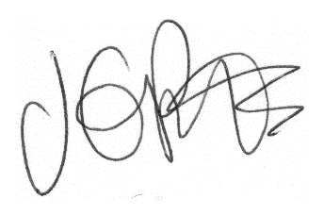

Jacqui Potts
Headteacher

