Tuesday 14th February, 2023

Dear parents/carers,

As part of our drive to promote and engage pupil interest in reading at Mount Carmel, we will be hosting World Book Day on Thursday 2nd March 2023. This is an opportunity for children to celebrate reading and this year, all year groups will have a focus on a specific author.

On this special day, your child can come to school either dressed as their favourite character from any book or in their pyjamas (for a bedtime story) to celebrate reading. We are well aware of the current rise in the cost of living and want to celebrate reading without any financial pressures to participate. We would love to see homemade costumes and do not expect parents to go to the expense of buying new costumes.

On this day, Year 6 will be heading out on an exciting trip to Manchester to meet the author Hannah Gold so we ask that Y6 wear their school uniform on this day (more information to follow for Y6).

During the week, children will participate in lots of exciting reading themed activities- sharing stories, researching an author and discussing new texts. Another exciting opportunity is our ‘World Book Day Competition’. Children will be asked to complete a poster, giving lots of information about their favourite author for the chance to participate in a draw to win some books! As always, each child will receive a World Book Day £1 token to be redeemed at a retailer of your choice.
It would be good to talk about children’s favourite books at home in preparation to discuss their ideas in class. Reading a range of texts is so important for our children to access learning and sharing books at home in addition to school is a fantastic way for our children to get engaged and talk about reading.

We look forward to celebrating reading together on Thursday 2nd March!
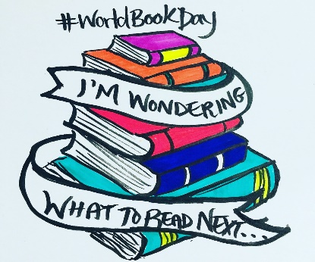
Thank you for your continued support,

Mrs McArdle

