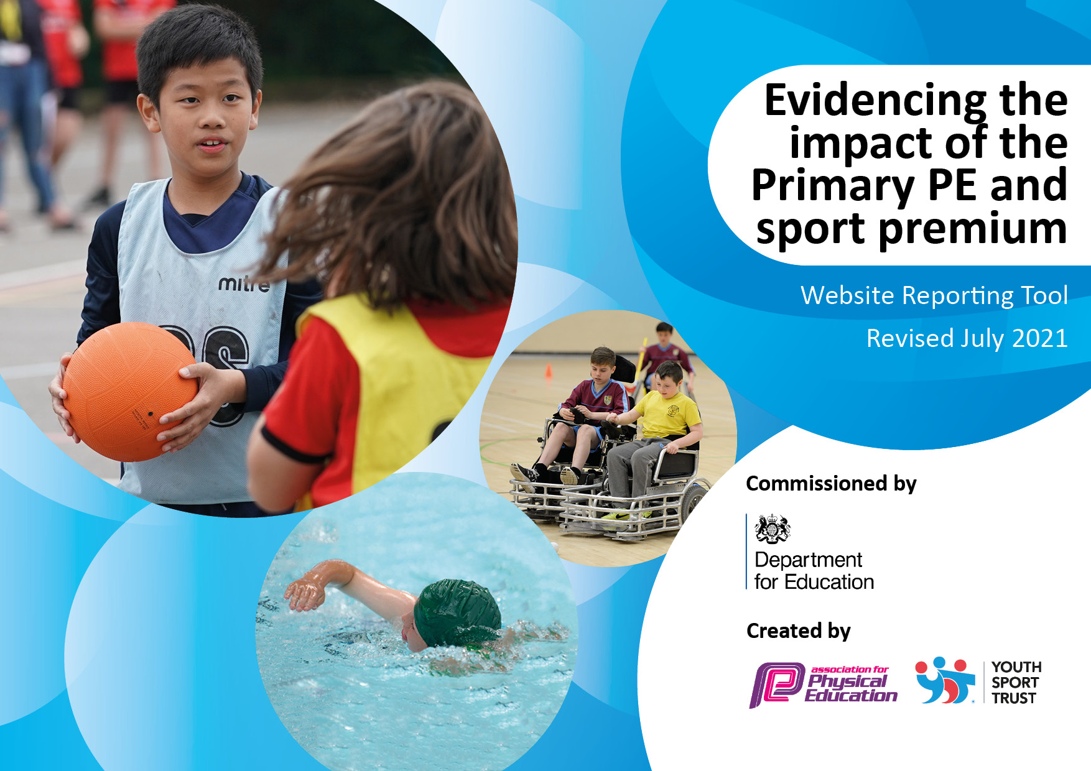
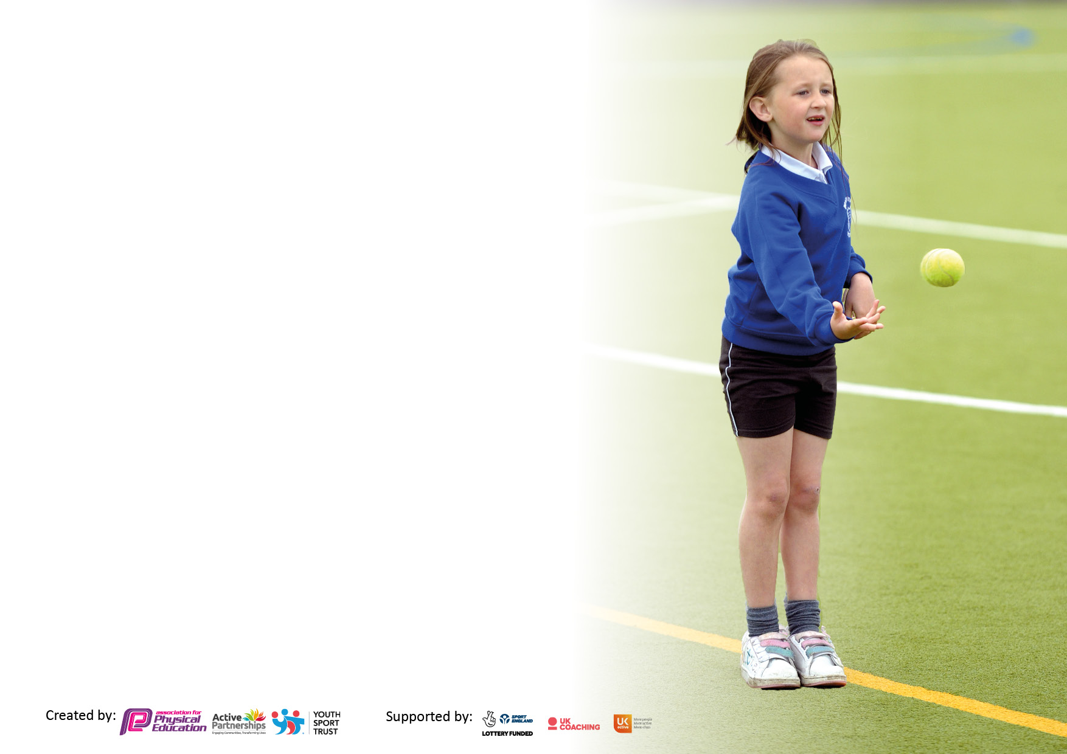

It is important that your grant is used effectively and based on school need. The Education Inspection Framework makes clear there will be a focus on ‘whether leaders and those responsible for governors all understand their respective roles and perform these in a way that enhances the effectiveness of the school’.

Under the Quality of Education Ofsted inspectors consider:
Intent - Curriculum design, coverage and appropriateness
Implementation - Curriculum delivery, Teaching (pedagogy) and Assessment
Impact - Attainment and progress

To assist schools with common transferable language this template has been developed to utilise the same three headings which should make your plans easily transferable between working documents.

Schools must use the funding to make additional and sustainable improvements to the quality of Physical Education, School Sport and Physical Activity (PESSPA) they offer. This means that you should use the Primary PE and sport premium to:

- Develop or add to the PESSPA activities that your school already offer
- Build capacity and capability within the school to ensure that improvements made now will benefit pupils joining the school in future years
- The Primary PE and sport premium should not be used to fund capital spend projects; the school’s budget should fund these.

Pleasevisitgov.ukfortherevisedDfEguidanceincludingthe5keyindicatorsacrosswhichschoolsshoulddemonstrate animprovement.Thisdocumentwillhelpyoutoreviewyourprovisionandtoreportyourspend.DfEencouragesschools to use this template as an effective way of meeting the reporting requirements of the Primary PE and sport premium.

We recommend you start by reflecting on the impact of current provision and reviewing the previous spend.

Schools are required to publish details of how they spend this funding, including any under-spend from 2019/2020, as well as on the impact it has on pupils’ PE and sport participation and attainment. All funding must be spent by 31st July 2022.

We recommend regularly updating the table and publishing it on your website throughout the year. This evidences your ongoing self-evaluation of how you are using the funding to secure maximum, sustainable impact. Final copy must be posted on your website by the end of the academic year and no later than the 31st July 2021. To see an example of how to complete the table please click HRE.

Details with regard to funding
Please complete the table below.

Total amount carried over from 2021/22 | £0
Total amount allocated for 2022/23 | £19,560
How much (if any) do you intend to carry over from this total fund into 2021/22? | £0
Total amount allocated for 2022/23 | £19,560
Total amount of funding for 2022/23. To be spent and reported on by 31st July 2022. | £19,560
Swimming Data
Please report on your Swimming Data below.

Meeting national curriculum requirements for swimming and water safety.

N.B. Complete this section to your best ability. For example you might have practised safe self-rescue techniques on dry land which you can then transfer to the pool when school swimming restarts.
Due to exceptional circumstances priority should be given to ensuring that pupils can perform safe self rescue even if they do not fully meet the first two requirements of the NC programme of study
What percentage of your current Year 6 cohort swim competently, confidently and proficiently over a distance of at least 25 metres?  N.B. Even though your pupils may swim in another year please report on their attainment on leaving primary school at the end of the summer term 2020.  Please see note above | 79%
What percentage of your current Year 6 cohort use a range of strokes effectively [for example, front crawl, backstroke and breaststroke]?  Please see note above | 53%
What percentage of your current Year 6 cohort perform safe self-rescue in different water-based situations? | 94%
Schools can choose to use the Primary PE and sport premium to provide additional provision for swimming but this must be for activity over and above the national curriculum requirements. Have you used it in this way? | Yes

Action Plan and Budget Tracking
Capture your intended annual spend against the 5 key indicators. Clarify the success criteria and evidence of impact that you intend to measure to evaluate for pupils today and for the future.

Academic Year: 2021/22 | Total fund allocated: £19,560 | Date Updated: October
Key indicator 1: The engagement of all pupils in regular physical activity – Chief Medical Officers guidelines recommend that primary school pupils undertake at least 30 minutes of physical activity a day in school |  |  |  | Percentage of total allocation:
 |  |  |  | 20%
Intent | Implementation |  | Impact
Your school focus should be clear what you want the pupils to know and be able to do and about  what they need to learn and to  consolidate through practice: | Make sure your actions to achieve are linked to your intentions: | Funding allocated: | Evidence of impact: what do pupils now know and what can they now do? What has changed?: | Sustainability and suggested next steps:
To assist teachers in ensuring children achieve 30 minutes of physical activity a day.  Raise awareness of the physical and mental health benefits of walking and help to create healthy habits for life.  Implement Yoga as part of the curriculum as a focus for mental health and wellbeing. | City in the Community to target less active pupils at lunchtime. (Extend this to the Infant department)  Walk to school reporting and awards to engage children and their families.  Teachers to deliver yoga sessions | £4000  Free  (Part of the subscription fee for other services) | Website and twitter show we are promoting a healthy lifestyle.  Children have a positive attitude towards leading healthy lifestyles.  Children are engaging in at least 30 minutes of physical activity a day in school.  Families choose to walk to school and children see the physical and mental benefits.  Children utilise skills they have developed in Yoga such as breathing techniques and mindfulness which can be used throughout the day and outside of school. | Pupils know how to play games that are active during playtimes.  Every class has the resources to engage in physical activity.  More families choose to walk to school and children develop healthy habits for life.  Monitor the impact of yoga through staff and pupil voice.
Key indicator 2: The profile of PESSPA being raised across the school as a tool for whole school improvement |  |  |  | Percentage of total allocation:
 |  |  |  | %
Intent | Implementation |  | Impact
Your school focus should be clear what you want the pupils to know and be able to do and about  what they need to learn and to  consolidate through practice: | Make sure your actions to achieve are linked to your intentions: | Funding allocated: | Evidence of impact: what do pupils now know and what can they now do? What has changed?: | Sustainability and suggested next steps:
Children are provided with various opportunities to learn about being healthy and staying active as part of the curriculum and through extra-curricular activities.  To assist teachers in developing children’s gross and fine motor skills through dance in EYFS.  To implement a sports leaders programme with children in UKS2. | PE Co-ordinator to attend subject leader meetings  Squiggle Whilst You Wiggle  (Uses dance and large movements to help children develop the fine muscle control they need for writing.) | Supply cover  (Part of pre-paid subscription) | Keeping up to date with best practice and delivering this information to staff in school.  Children are physically active. | Sharing good practice between schools to ensure we are always delivering the best for our pupils.

Key indicator 3: Increased confidence, knowledge and skills of all staff in teaching PE and sport |  |  |  | Percentage of total allocation:
 |  |  |  | 53%
Intent | Implementation |  | Impact
Your school focus should be clear | Make sure your actions to | Funding | Evidence of impact: what do | Sustainability and suggested
what you want the pupils to know | achieve are linked to your | allocated: | pupils now know and what | next steps:
and be able to do and about | intentions: |  | can they now do? What has
what they need to learn and to |  |  | changed?:
consolidate through practice:
To maintain quality teaching of the PE curriculum by all staff so children receive high quality teaching and learning.  To ensure teachers are confident in delivering PE sessions through the use of the Get Set 4 PE scheme,. | City coaches support teachers in the delivery of the curriculum.  Teachers to increase their confidence in delivering a wide range of sports and activities through following the Get Set 4 PE scheme. | £10,000  £0  (supply cover to monitor delivery and support teachers)  £550 | Teachers are using framework to deliver PE lessons. Observations and assessment demonstrate high quality teaching and learning.  Teachers are confident in delivering and assessing a wide range of sports and activities. Children are able to perform FMS confidently through gymnastics and orienteering. | Up to date training on delivering the curriculum. Teachers are confident in delivering PE.  Key PE sessions will not continue next year as they will be replaced with getset4pe so teachers can implement the PE curriculum after working with the Key PE coaches this year.
Key indicator 4: Broader experience of a range of sports and activities offered to all pupils |  |  |  | Percentage of total allocation:
 |  |  |  | 24%
Intent | Implementation |  | Impact
Your school focus should be clear | Make sure your actions to | Funding | Evidence of impact: what do | Sustainability and suggested
what you want the pupils to know | achieve are linked to your | allocated: | pupils now know and what | next steps:
and be able to do and about | intentions: |  | can they now do? What has
what they need to learn and to |  |  | changed?:
consolidate through practice:
Additional achievements:  Increased participation in children leading a healthy and active lifestyle.  Purchase equipment for Get Set 4 PE which offers a wide range of sports and activities to offer a wider range of activities to the pupils  Provide children with the opportunity to apply skills learnt in core swimming lessons to achieve more than 25m. | Dance sessions (motion dance)  City in the Community provide additional activities to introduce new sports or activities to the children.  Teachers to deliver fully resourced sessions.  Purchase top up swimming lessons for children who require more experience in the water and have the opportunity to gain 50m award. | £2650  (Part of the subscription fee for other services)  (Part of the subscription fee for other services)  £1973.37 so far | Children are participating in more after school clubs.  Children are enthusiastic about the role of sport in their lives and see the relevance of living a healthy lifestyle.  Children want to participate in after school clubs.  Children are confident swimmers and achieved 25m. Children should have the opportunity to gain 50m award. | Children will continue to attend after school clubs as they see the benefit.  Continue to give children the opportunity to part in a broad range of sports. Continue to encourage physical activity during the school day.  Make after school clubs available across all year groups in a broad range of sports and activities.

Key indicator 5: Increased participation in competitive sport |  |  |  | Percentage of total allocation:
 |  |  |  | %
Intent | Implementation |  | Impact
Your school focus should be clear | Make sure your actions to | Funding | Evidence of impact: what do | Sustainability and suggested
what you want the pupils to know | achieve are linked to your | allocated: | pupils now know and what | next steps:
and be able to do and about | intentions: |  | can they now do? What has
what they need to learn and to |  |  | changed?:
consolidate through practice:
Provide opportunities for children to take part in intra/ inter competitive sports  Provide opportunities for exceeding pupils to engage in club activities. | Competitions and St. Matthew’s (feeder school) including football, tag rugby, netball and rounders.  Manchester Schools’ Football Association. | £30 | Increased opportunities to compete in inter-sport competitions.  Children are taking part in inter-sport competitions (registers)  Children are developing teamwork, resilience, determination, self-belief, honesty and respect.  Children attend football trials. | Sporting networks are well-established.  All pupils have experience of competitive sports and are developing the School Games Values.  Children have the chance to represent Manchester and potentially play for clubs.

Signed off by
Head Teacher:
Date:
Subject Leader:
Date:
Governor:
Date:

