Dear Parents/Carers,

Online Free School Meal Eligibility Checker

We urge all parents to apply for free school meals using an on-line form via Manchester City Council website. Even if you know/think you are not eligible. This is because once you have applied, your details will stay live on the checker. The checker updates itself every day so if there are any changes to your circumstances this will automatically pick you up and you will be entitled straight away, even if this is just for a couple of days, you are covered immediately and we are notified.

As well as yourselves, school benefits from this because we get funding for your child if they are entitled. In the current climate, with budgets so tight, every penny helps.

To apply, go to www.manchester.gov.uk and click on ‘Benefits and Support’…
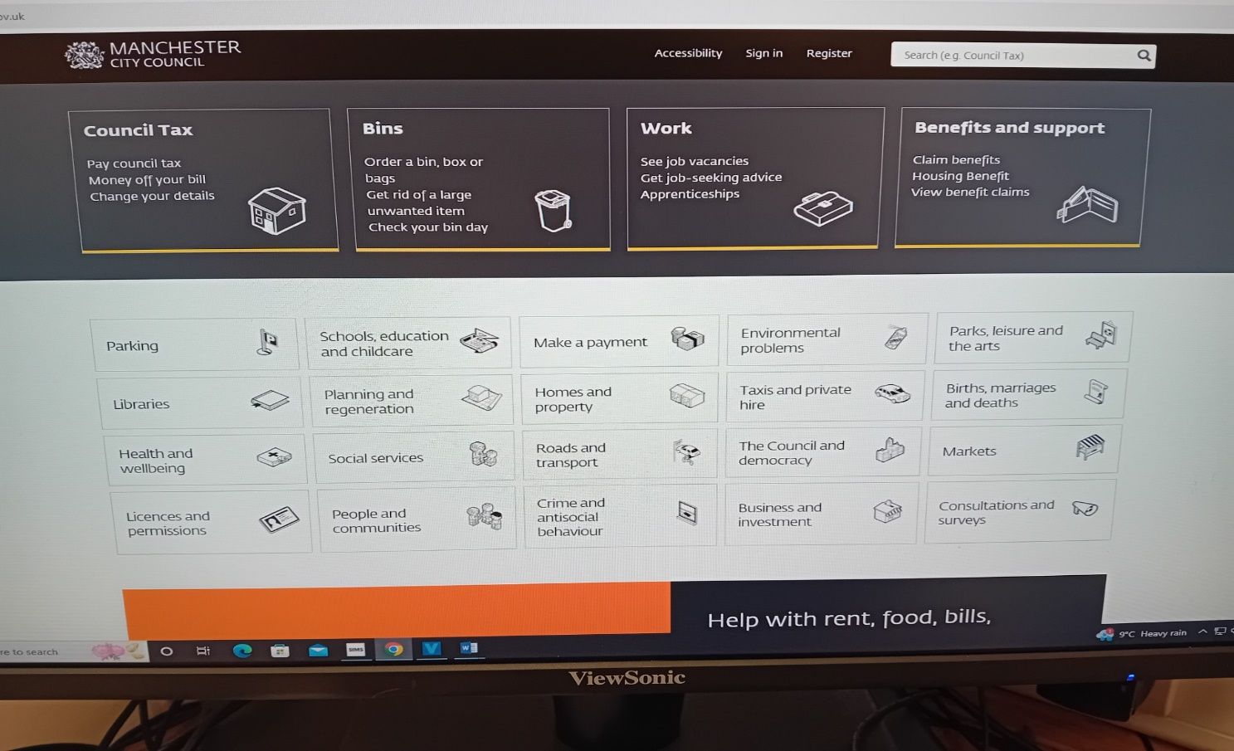

Then click on ‘Free School Meals’…
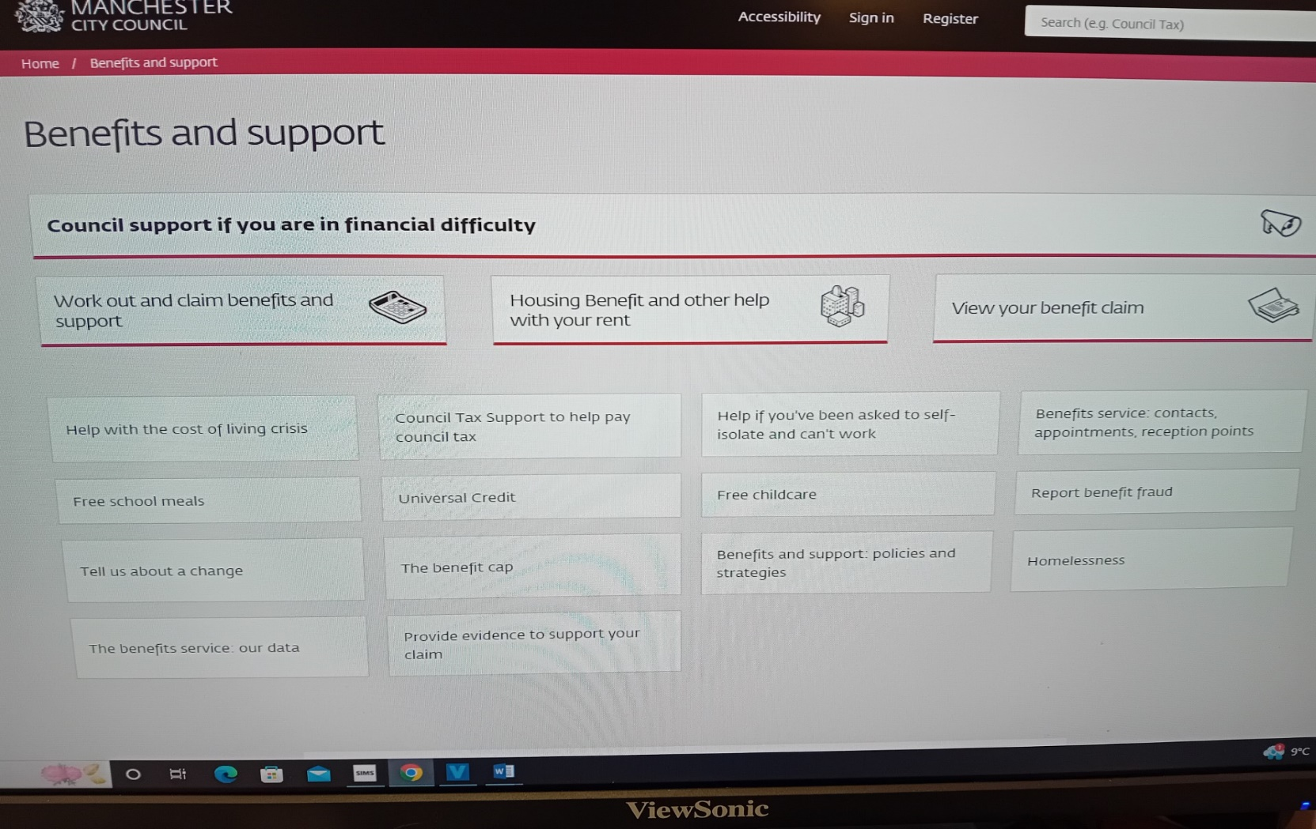
Then click on ‘Apply for Free School Meals in Term-Time’…
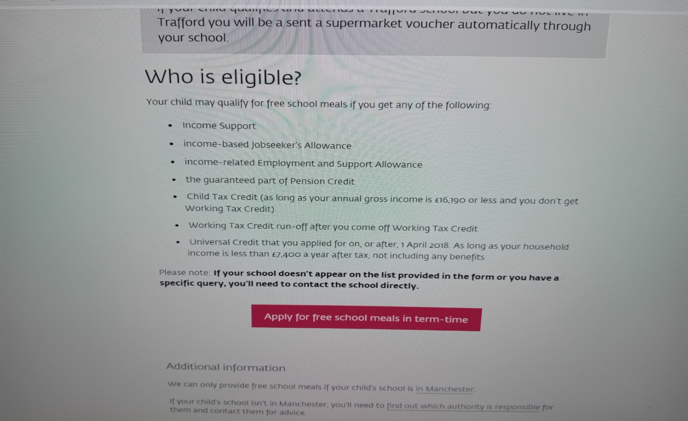

This is the portal you will see…
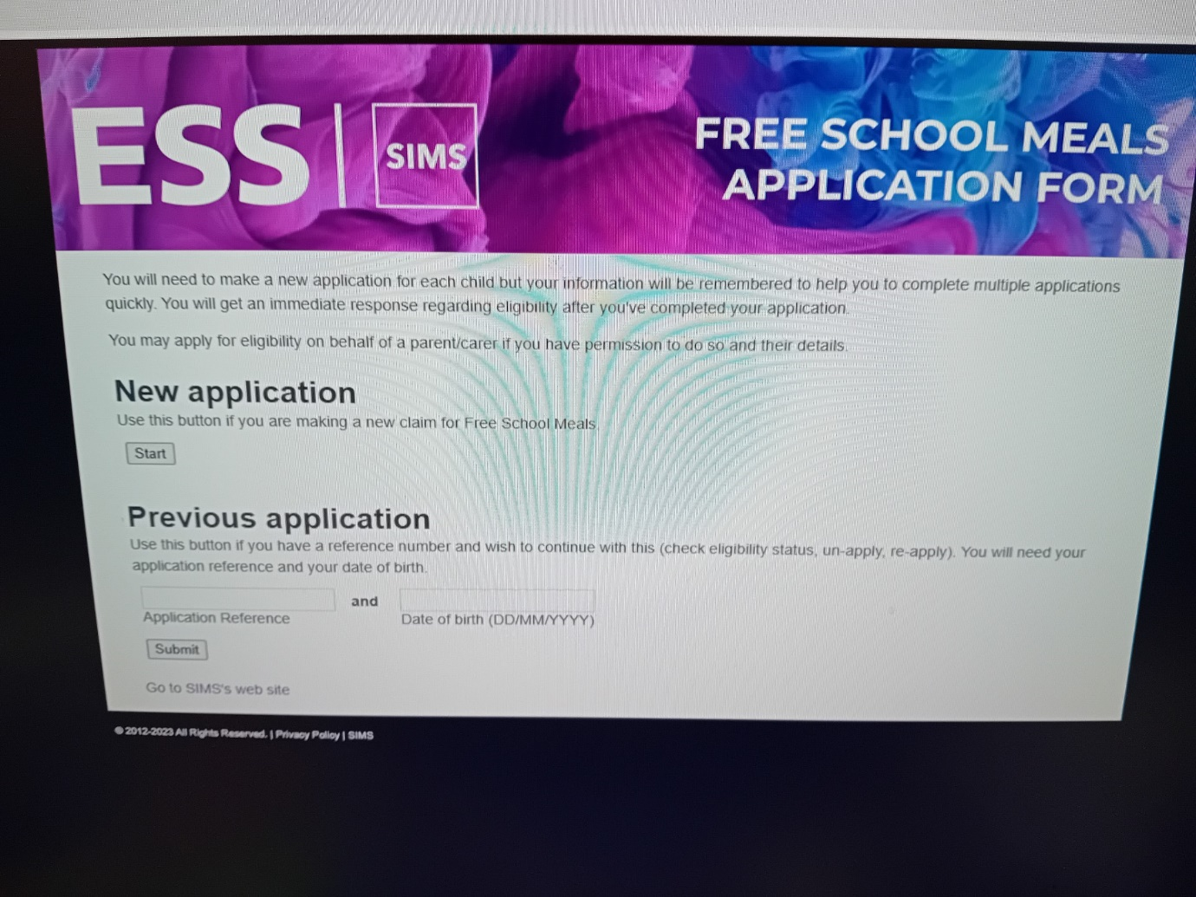

Please complete the application form on the portal and you will be informed if you are eligible or not. We will also receive confirmation of this.

This is a great way to ensure eligibility is never missed and will benefit yourselves and the school.

Your sincerely

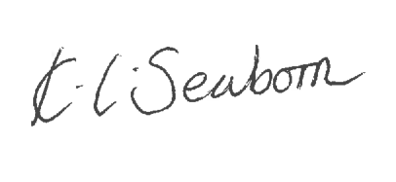

K. Seaborn
Head Teacher

