11th October 2018

Dear Parents/Carers,

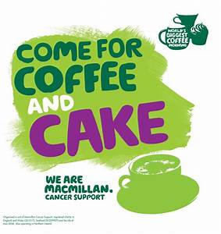

Come and join us for our Macmillan coffee morning in our infant hall on Tuesday 16th October from 9am. We will have lots of lovely cakes and treats available to buy along with a nice cup of tea or coffee all in aid of a fantastic cause.

If there are any budding bakers or supermarket shoppers that would like to donate a cake for the coffee morning please drop these off with your child’s teacher on Tuesday morning.

Thank you for your continued support

Mr. M Hughes

