02/11/2021

Dear Parents and Carers,

This is to let you know that last night, after a long meeting where all of our consultation questions and comments were looked at and carefully considered, our governing board made the decision for Mount Carmel to become an academy and to join the Emmaus Catholic Academy Trust. This will happen on the first of December 2021.

The governors want to thank you all for your engagement with the process and for the careful way in which questions were asked and comments given. This has been a long process but now we can look forward to the benefits that being in the Trust will bring for our children.

I will let you know if and when there is any more information.

Best wishes,

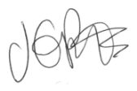

Jacqui Potts

