05/02/2020

Dear Parents,

As you are aware we had our Section 48 inspection last week, this is an inspection of our Catholic nature. We had three inspectors who spent the day talking to our children, staff, governors and parents. They also observed lessons, various collective worship and looked at the children’s work. I am delighted to say that their judgement was that we are still an outstanding Catholic school.

Please read our report, you will see that top of the list of strengths for our school are our wonderful children but we knew that already!

We have had a little celebration but will now we continue the hard work that goes into making Mount Carmel the special family that we are. This report belongs to us all, children, parents, staff and our parish community and I want to thank you all for your support for our school, we couldn’t do it without you.

Thank you all again,

With warmest regards,

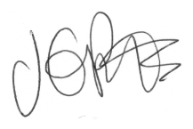

Jacqui Potts
(Very Proud) Headteacher

