17/01/2022

Dear Parents and Carers,

As part of the national celebrations this year for the Platinum Jubilee of Her Majesty the Queen, we have been granted an extra bank holiday in June. This weekend of celebration already falls within our half term holiday so we will take this extra holiday on Thursday 14th April, extending our Easter break by 1 day. School will therefore break up for the Easter break on Wednesday 13th April 2022 at 1.30.

On looking at our term date sheet on the web site I have noticed that one of our teacher training days has not been included on it. School will be closed for children, not staff, on Monday 4th July 2022. I apologise for this oversight.

Best wishes,

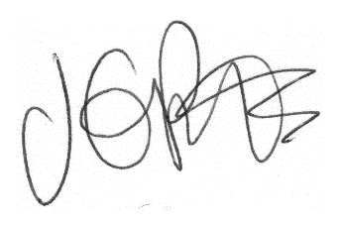

Jacqui Potts

