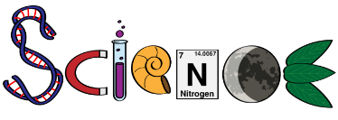
3rd March, 2022

Dear Parent/Carer,

British science week this year will be taking place during March. To launch a week of fun and exciting science activities in school, ‘Mad Science’ will be bringing an educational workshop to school on Friday 11th March, to inspire the Mount Carmel Scientists of the future!

As always, we try to keep the cost to a minimum. We are requesting a contribution of £1.70 per child to cover the cost of this excellent workshop.

If you wish your child to participate in this workshop please complete and confirm payment of £1.70 through ParentPay, this also acts as consent for the workshops.

Please pay and confirm through ParentPay by Wednesday 9th March.

There will be lots going on during Science week and further updates will follow.

We hope ‘Science Week’ will be great fun and that the children will learn a great deal.

Yours sincerely,
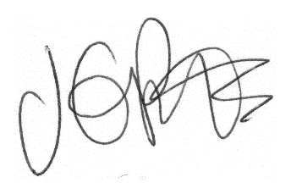
Jacqui Potts
HEADTEACHER

