11/05/2020

Dear Parents and Carers,

Yesterday, the Prime Minister announced that schools may reopen on 1st June for children in Reception, Year 1 and Year 6. While media speculation indicated that an
announcement of this nature would be made, school leaders have received the
information about schools re-opening along with the rest of the public. So at this point, I do not have any further information to give you and would not be in a position to answer any of your questions.

Please be assured that the safety of your children, and the safety of our staff, will be at the forefront of our minds when making any plans.

While we understand you are anxious to find out more information, we would appreciate this time to be able to plan for the next steps of opening school safely for both adults and children and this will take some time to get right. We are waiting to receive more information from the Government about what this means for school but in the meantime nothing has changed and I will provide further information in the coming days and weeks once I am able to do so.

I wish you and you families all the best and I hope to see you all soon,

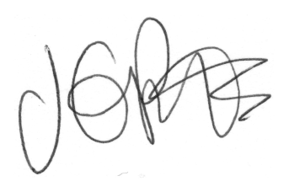

Jacqui Potts

