08/01/21

Dear Parents,

This has been a very difficult week for us all and now that we have reached Friday I want to thank you all for your support.

Our school is not closed but we have cut the capacity for face to face learning, this is to meet the government guidance that says:

“During the period of national lockdown, schools, should allow only vulnerable children and young people and the children of critical workers to attend. All other pupils and students should not attend and should learn remotely until February half term.”

I want to thank those of you that have carefully considered whether or not to send your child to school, especially if you are a critical worker but have someone at home to look after your child. Limiting attendance at school is about reducing the number of social contacts in the community which will bring down the infection rate and lead to the end of this awful situation for us all.

Finally, I would like to remind you that if anyone in your household has a temperature, a persistent cough or loss of taste or smell, then you must all isolate for 10 days or until the ill person has had a test and a negative result. Please do not send your child to school while you wait for the outcome of the test.

Thank you again for your support,

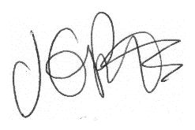

Jacqui Potts

