 | Week 1 | Week 2 | Week 3 |  | Week 4 | Week 5 | Week 6 |  | Week 7 | Week 8 | Week 9 |  | Week 10 |  | Week 11 | Week 12 |  | Week 13 | Week 14
 | Autumn 1 |  |  |  |  |  |  |  |  | Autumn 2
Focus Text | 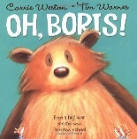  Oh Boris – Weston |  | Bumblebear – Shireen  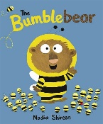 |  |  |  | 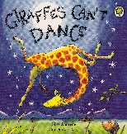  Giraffe’s Can’t Dance – Andrea |  |  | Pirate’s Love Underpants – Freedman  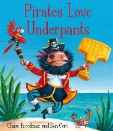  Captain Flynn and the Pirate Dinosaur - Andrea  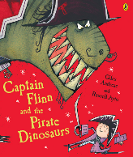 |  |  |  |  |  |  |  | The Snowman – Briggs  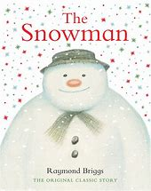
You Choose – Goodhart
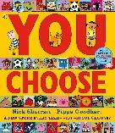

Writing Outcomes | Labelling, sequencing, lists, simple sentences to recount |  |  |  |  |  |  | Labelling, sequencing, lists, simple sentences, poetry. |  | Simple sentences, character descriptions, letters, instructions (making a birdhouse)
Focus GAPS | -Daily phonics  -Capital letters  -Full stops  -Finger spaces  -Letter formation |  |  |  |  |  |  |  |  | -Daily phonics  -Capital letters  -Full stops  -Finger spaces  -Letter formation
 | Week 1 | Week 2 | Week 3 |  | Week 4 | Week 5 | Week 6 |  | Week 7 | Week 8 | Week 9 |  | Week 10 |  | Week 11 | Week 12 |  | Week 13 | Week 14
 | Spring 1 |  |  |  |  |  |  |  |  | Spring 2
Focus Text | You Must Bring a Hat – Phillip  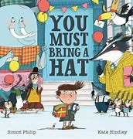  I Want My Hat Back – Klassen  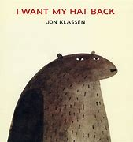  Millie’s Marvellous Hat – Kitamura  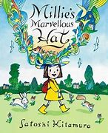 |  |  |  |  | Supertato – Hendra  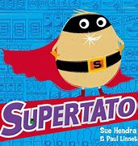 |  |  |  | 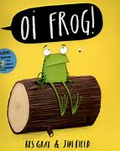  Oi Frog – Gray |  | 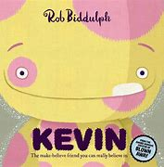  Kevin – Biddulph |  | 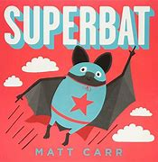  Superbat – Carr |  |  | 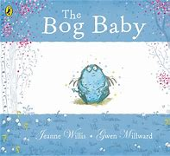  Bog Baby – Willis
Writing Outcomes | Invitation, information texts, speech bubbles, retelling of a story, character descriptions. |  |  |  |  |  |  |  |  | Poetry, instructions, descriptions, letters, diary, comic strip.
Focus GAPS | -Daily Phonics  -Capital letters  -Full stops  -Adjectives  -Conjunction ‘and’  -finger spaces  -Letter formation |  |  |  |  |  |  |  |  | -Daily Phonics  -Capital letters  -Full stops  -Adjectives  -Conjunction ‘and’, ‘because’  -finger spaces  -Letter formation
 | Week 1 | Week 2 | Week 3 |  | Week 4 | Week 5 | Week 6 |  | Week 7 | Week 8 | Week 9 |  | Week 10 |  | Week 11 | Week 12 |  | Week 13 | Week 14
 | Summer 1 |  |  |  |  |  | Summer 2
Focus Text | 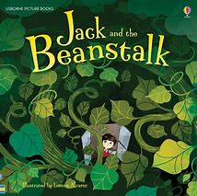  Jack and the Beanstalk –  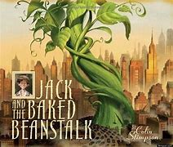  Jack and the Baked Bean Stalk – Stimpson |  |  | Bad Seed – John  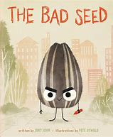  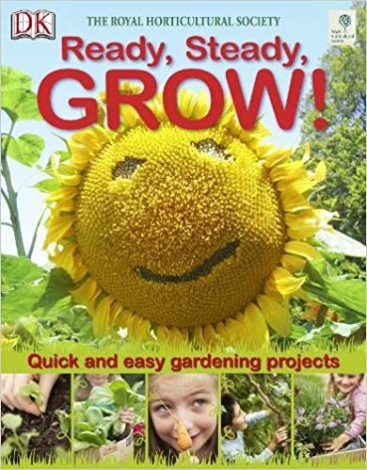  Ready, Steady, Grow – DK |  |  | The Lighthouse Keepers Lunch – Armitage  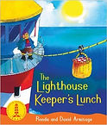  At the Beach – Harvey  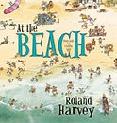  Splash Anna Hibiscus – Atinuke  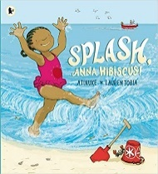  Seaside Poems – Bennett  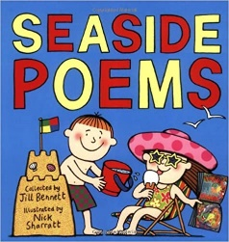
Writing Outcomes | Letters, poems, retelling the story, instructions, alternative story |  |  |  |  |  | Postcards, letters, poems.
Focus GAPS | -Daily phonics  -Capital letters  -Full stops  -Adjectives  -Conjunction ‘and’, ‘because’  -Question sentences  -Finger spaces  -Letter formation |  |  |  |  |  | -Daily phonics  -Capital letters  -Full stops  -Adjectives  -Conjunction ‘and’, ‘because’  -Question sentences  -Exclamation marks  -Finger spaces  -Letter formation

