 | Week 1 | Week 2 | Week 3 |  | Week 4 | Week 5 |  | Week 6 | Week 7 | Week 8 | Week 9 | Week 10 | Week 11 | Week 12 |  | Week 13 | Week 14
 | Autumn 1 |  |  |  |  |  |  |  |  | Autumn 2
Focus Text | Little Red Riding Hood – traditional tale  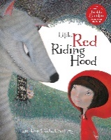  Little Red - Woollvin  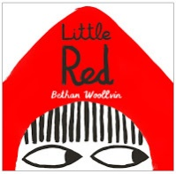  Mixed up Fairy Tales – Robinson and Sharrat  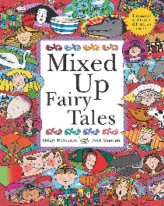 |  |  |  | 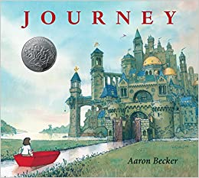  Journey – Becker |  | 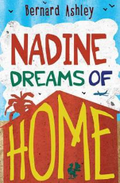  Nadine Dreams of Home – Ashley |  |  | The Boy Who Biked the World – Humprehys  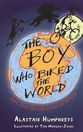 |  |  | How to wash a Woolly Mammoth – Hindley  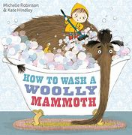  Stone Age Boy – Kitamura  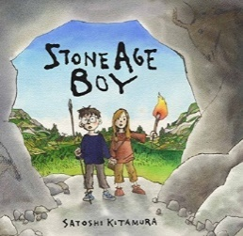
Writing Outcomes | -Retell story  -Alternative narrative |  |  |  | -Sequel to the story  -Dialogue |  | -Letter in role as Nadine  -Non-Chronological report about the UK for a new arrival |  |  | -Diary entry/travel journal |  |  | -Instructional writing  -Dialogue between boy and Ugg  -Diary of the boy’s life
Focus GAPS | - Daily Spellings  Revision of previous learning +  -Simple paragraphing (eg group related material into paragraph & story mapping)  -Adverbials for time  -Subordinate clauses, extending the range of sentences with more than one clause by using a wider range of conjunctions, including when, if, because and although.  -Use the determiner a or an accordingly  -Specific adjective, verbs & adverbs including scientific language for explanation text |  |  |  |  |  |  |  |  | -Daily Spellings  Revision of previous learning +  -Adverbials for time and cause eg. suddenly, silently, eventually, cautiously, timidly.  -Identify and create complex sentences using a range of conjunctions e.g. when, while, before, after  -Embed past tense verbs  -Imperative verbs for instructions  -Introduction of punctuating direct speech (dialogue) & synonyms for said  -Use of pronoun to ensure cohesion
 | Week 1 | Week 2 | Week 3 |  | Week 4 | Week 5 |  | Week 6 | Week 7 | Week 8 | Week 9 | Week 10 | Week 11 | Week 12 |  | Week 13 | Week 14
 | Spring 1 |  |  |  |  |  |  |  |  | Spring 2
Focus Text | Ali’s Story – Glynne  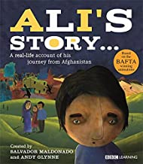 |  |  |  | 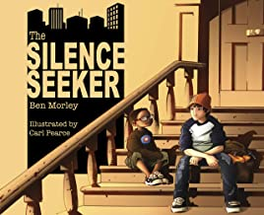  The Silence Seeker – Morley and Pearce  Photographs of by the canal, skatepark and tips. |  |  | 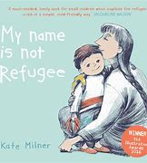  My Name is not Refugee – Milner |  | The Boy who Grew Dragons – Shepherd  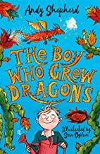 |  |  | Wangari Trees of Peace – Winter |  |  | Don’t – Rosen  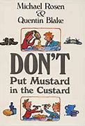
Writing Outcomes | -A letter from Ali telling his parents that he has arrived safely  -Character study to understand Ali |  |  |  | -Rewrite part of the story where the boy takes the refugee to new places and set it in Manchester (innovating the orginal) |  |  | -Own narrative about starting a new school |  | -Letter from Chipstick to Grandad  -Information text about their own magical plant |  |  | -Instructions for peace  -Persuasive letter |  |  | -Rhyming poem
Focus GAPS | Daily Spellings  Revision of previous learning +  -Paragraphing – cohesion from paragraph to paragraph  -Explore and identify main and subordinate clauses in complex sentences.  -Identify and use inverted commas to punctuate direct speech  -To use adjectives, verbs, adverbs and preposition with more appropriacy  -Adverbials for time cause and place e .g. Above, Beneath, Within, Outside, Beyond.  -Use of figurative language – eg. simile, metaphor  Apostrophe for both singular and plural possessive apostrophe |  |  |  |  |  |  |  |  | Daily Spellings  Revision of previous learning +  -To use a range of conjunctions, adverbs and prepositions to show time, place and cause.  -Explore, identify and create complex sentences using a range of conjunctions e.g. if, although, so.  -Explore the use of emotive language, hyperbole and rhetorical question in 1st person narrative  -Investigate ‘voice’ in letter writing to ensure appropriacy of language  -Use perfect form of verbs using have and has to indicate a completed action
 | Week 1 | Week 2 | Week 3 |  | Week 4 | Week 5 |  | Week 6 | Week 7 | Week 8 | Week 9 | Week 10 | Week 11 | Week 12 |  | Week 13 | Week 14
 | Summer 1 |  |  |  |  |  |  | Summer 2
Focus Text | 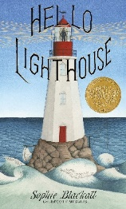  Hello Lighthouse - Blackall |  |  | Lights on Cotton Rock – Litchfield  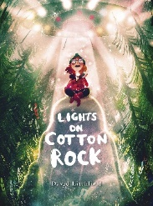 |  |  |  | Marcy and the Riddle of the Sphinx – Stanton  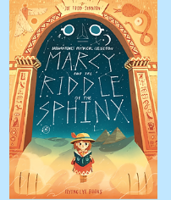 |  | Ancient Egypt – DK  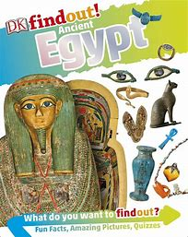  Meet the Ancient Egyptians – Davies  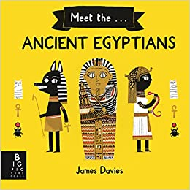 |  | The Legend of Tutankhamun – Morgan  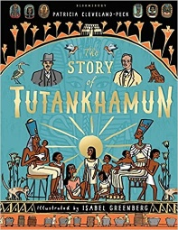  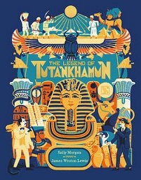  The Story of Tutankhamun – Cleveland Peck
Writing Outcomes | -Diary entry  -Informal letter  -Setting Description |  |  | -Setting description  -Narrative involving action, dialogue, description |  |  |  | -Adventure story |  | -Instructions for mummification  -Non-chronological report about an aspect of Ancient Egypt |  | -Diary in role as Carter  -Newspaper article exploring ‘the curse’
Focus GAPS | Daily Spellings  Revision of previous learning +  -Paragraphing – cohesion identifying suitable headings  -Subordinate clauses, extending the range of sentences with more than one clause by using a wider range of conjunctions  -Use figurative language in poetic writing  -Developing use of precision in adjectives, verbs, adverbs and prepositions in different forms of writing  -To use dialogue to show character and move the action on |  |  |  |  |  |  | Daily Spellings  Revision of previous learning +  -Explore, identify and create complex sentences using a range of conjunctions e.g. when, if because, although, while, since, until, before, after, so  -Use the comma to separate clauses in complex sentences where the subordinate clause appears first  -Use of the perfect form of verbs  -Explore persuasive elements of speech – refrain, use of personal pronoun, rhetorical question, imperative verb

