 | Week 1 | Week 2 | Week 3 |  | Week 4 | Week 5 | Week 6 | Week 7 | Week 8 | Week 9 | Week 10 | Week 11 | Week 12 |  | Week 13 | Week 14
 | Autumn 1 |  |  |  |  |  |  |  | Autumn 2
Focus Text | Lost Happy Endings – Duffy  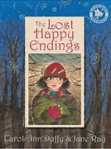  How to Live Forever – Thompson  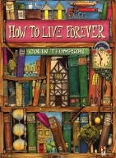 |  |  |  | Grimm Tales – Pullman  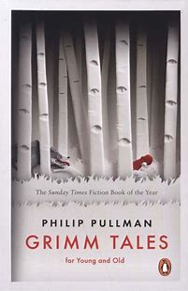  Faery Tales – Duffy  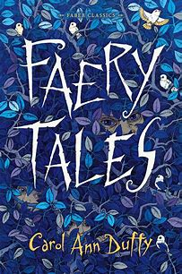  Hansel and Gretal – Gaiman  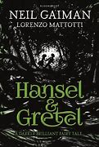 |  |  |  | Greek Myths – Williams  Pandora’s box  Theseus and the Minotaur  Perseus and Medusa  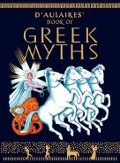  Percy Jackson and the Lightening Thief – Riordan  (extract about Medusa)  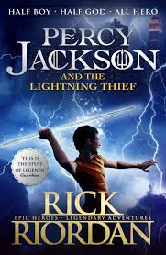 |  |  | 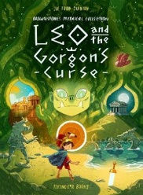  Leon and the Gorgon’s Curse – Stanton |  |  | A Boy Called Christmas – Haig  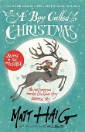
Writing Outcomes | -Alternative endings  -setting/character descriptions  -Retell from character’s POV  -dialogue between characters  -Persuasive writing (get Peter to read the book at the end of the story) |  |  |  | -Alternative versions  -Retelling from a different POV  -Character descriptions |  |  |  | -character descriptions  -recounts  -non-chronological report about a Greek monster of their own creation. |  |  | -Adventure/saga writing  -Dialogue |  |  | -Persuasive letter  -Instructions
Focus GAPS | Daily Spellings  Revision of previous learning +  -Appropriate use of paragraphing for different text types  -Use of fronted adverbials for when e.g. As the clock struck twelve, the tadpoles plummeted from the sky. Use a comma after the fronted adverbial  -Use inverted commas to punctuate direct speech, developing characterisation using action, dialogue and description.  -Appropriate pronouns  e.g. third person in narratives  -Use nouns for precision  -Standard English verb inflections e.g. We were instead of we was |  |  |  |  |  |  |  | Daily Spellings  Revision of previous learning +  -Link ideas across paragraphs using fronted adverbials for when and where e.g. Several hours later…, Back at home…  -Expanded use of conjunctions appropriate to texts eg causal  -Exploration of language choice to show formality and tone when producing fiction and non-fiction writing  -Specific noun, adjective, verb, adverb & preposition appropriate to context eg. technical language and precise amounts in instructional writing
 | Week 1 | Week 2 | Week 3 |  | Week 4 | Week 5 | Week 6 | Week 7 | Week 8 | Week 9 | Week 10 | Week 11 | Week 12 |  | Week 13 | Week 14
 | Spring 1 |  |  |  |  |  |  |  | Spring 2
Focus Text | Who Let the God’s Out – Evans  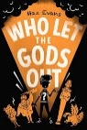 |  |  |  | The Lost Thing – Tan  A Visitor’s Guide to Ancient Greece – Usborne  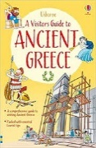  So You Think You’ve Got It Bad? A Kid’s Life in Ancient Greece – Strathie  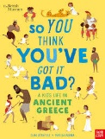 |  |  |  | Krindlekrax – Ridley  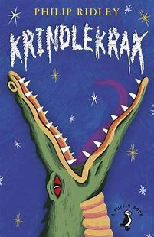 |  |  | Wisp A Story of Hope – Fraillon  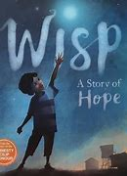  Refugees and Migrants – Roberts  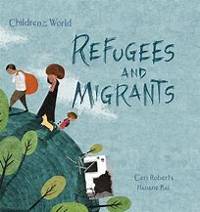
Writing Outcomes | -Care guide for Cerberus  -Information text about an immortal creature  -Job application letter from an immortal to Plutus (formal letter) |  |  |  | -Tourist leaflet for ancient Greece  -Postcard writing  -Letters  -Non-chronological reports |  |  |  | -Explanation text  -Writing with empathy  -Alternative ending narrative |  |  | -Retell part of the story from the POV of the wisp  -Prayer/poem of hope
Focus GAPS | Daily Spellings  Revision of previous learning +  -With support select the appropriate language and structures for the audience and purpose.  -Learn manipulation of multi-clause sentences  -Create sentences with fronted adverbials for where e.g. In the distance, a lone animal caterwauled. Use a comma after the fronted adverbial.  -Link ideas across paragraphs using fronted adverbials for where e.g. Back at the side street,…  -Capture voice of character through language choice and appropriate punctuation |  |  |  |  |  |  |  | Daily Spellings  Revision of previous learning +  -Develop settings using vocabulary to create emphasis, atmosphere, or suspense.  -Explore, identify, collect and use noun phrases e.g. the snake-haired creature with the eyes of death.  -Use inverted commas and other punctuation to indicate direct speech ant that gives clues about character’s feelings e.g. Arthur announced worriedly, “You can’t expect me to climb that!”  -Explore and use the formal elements of journalistic writing
 | Week 1 | Week 2 | Week 3 |  | Week 4 | Week 5 | Week 6 | Week 7 | Week 8 | Week 9 | Week 10 | Week 11 | Week 12 |  | Week 13 | Week 14
 | Summer 1 |  |  |  |  |  | Summer 2
Focus Text | Horrible Histories Rotten Romans  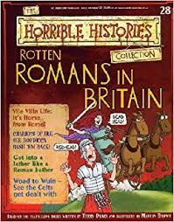  The Roman Soldiers’ Handbook – Usborne  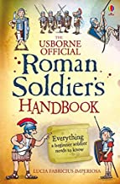 |  |  | Boudicca – Llewellyn  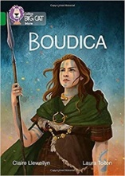  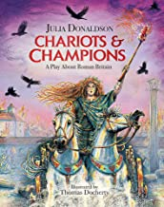  Chariots and Champions – a play about Roman Britain – Donaldson  Clip of Boudicca persuading her men to follow her |  |  | Flotsam – Wiesner  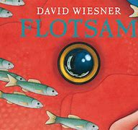  What a Waste: Rubbish, Recycling and Protecting our Planet – French  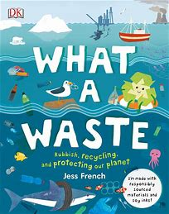  The Tindims – Gardner  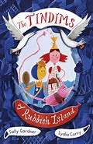
Writing Outcomes | -Diary of an ineffectual Roman soldier  -Job advertisement for a Roman Soldier |  |  | -Boasting poem  -Persuasive speech in role as Boudicca |  |  | -Newspaper article  -Persuasive letter  -Information leaflet  -Writing a balanced argument
Focus GAPS | Daily Spellings  Revision of previous learning +  -With growing awareness select the appropriate language and structures for the audience and purpose.  -Use paragraphs to organise writing in fiction, beginning a new paragraph to reflect a change of speaker, location and time.  -Create and use complex sentences with adverb starters in own writing. Use a comma to separate the clauses.  -Use inverted commas and other punctuation to indicate direct speech. Start a new paragraph when a new speaker says something.  -Identify, select and effectively use pronouns e.g. second person in persuasion (you, your, yours). |  |  |  |  |  | Daily Spellings  Revision of previous learning +  -Use paragraphs in fiction and non-fiction confidently and appropriately.  -Create sentences with fronted adverbials for when and where and begin to expand the multi-clause sentence  e.g. Moments later, holding his enemy high above his head, Hercules appeared on the hillside  -Improvise and compose dialogue, demonstrating their understanding of Standard English and non-Standard English when appropriate  -Identify, select and effectively use pronouns e.g. first person for diaries, and first person narratives and recounts (I, me, my, mine, we, us our, ours).

