 | Week 1 | Week 2 | Week 3 |  | Week 4 |  | Week 5 | Week 6 | Week 7 | Week 8 |  | Week 9 | Week 10 | Week 11 | Week 12 |  | Week 13 | Week 14
 | Autumn 1 |  |  |  |  |  |  |  |  | Autumn 2
Focus Text | The Great Kapok Tree – Cherry  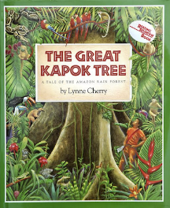 |  |  |  |  | The Explorer - Rundell  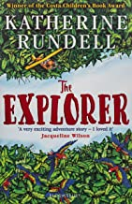 |  |  |  | 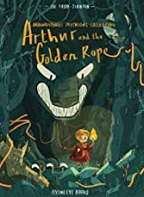  Arthur and the Golden Rope – Stanton |  |  |  | Explore Vikings  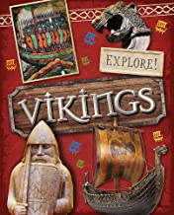  100 facts Vikings  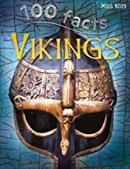
Writing Outcomes | -Persuasive formal letter  -Setting description |  |  |  |  | -Adventure story based on travelling through a dangerous place  Dialogue to convey character and move the action on  -Writing in role as Fred after the plane crash  -Postcard writing from a faraway place |  |  |  | -Creation of their own myth (setting description to create atmosphere, character description, dialogue and action) |  |  |  | -Non-chronological page about an artefact
Focus GAPS | Daily Spellings  Revision of previous learning +  -Link ideas across paragraphs using adverbials for time, place and numbers e.g. later, nearby, secondly.  -Create complex sentences by adding a relative clause using a relative pronoun: who, which, where, whose, when, that  -Create and punctuate complex sentences using ed opening clauses e.g. Exhausted from the climb, she collapsed in a heap.  -Demarcate complex sentences using commas in order to clarify meaning.  -Identify and use brackets to indicate parenthesis, e.g. in formal writing: The polar bear (Ursus maritimus) inhabit arctic sea ice and continental coastlines.  -Show a growing understanding of formality and register in their language choices. |  |  |  |  |  |  |  |  | Daily Spellings  Revision of previous learning +  -With growing confidence Link ideas across paragraphs using adverbials for time, place and numbers  -Create and punctuate complex sentences using ing opening clauses, e.g. Grinning with anticipation, Beowulf launched himself at the lurching creature.  -Show characterisation through the use of description, action and dialogue (which is accurately punctuated)  -Explore, identify, collect and use noun phrases e.g. Beowulf stared in horror at the destruction in the old hall shocked at the carnage and bloodied sight in front of him.
 | Week 1 | Week 2 | Week 3 |  | Week 4 |  | Week 5 | Week 6 | Week 7 | Week 8 |  | Week 9 | Week 10 | Week 11 | Week 12 |  | Week 13 | Week 14
 | Spring 1 |  |  |  |  |  |  |  |  | Spring 2
Focus Text | 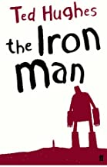  The Iron Man – Hughes  Film – The Iron Giant  Iron Man Poem – Williams |  |  |  |  |  | Leon and the Place Between – McAlister and Baker Smith  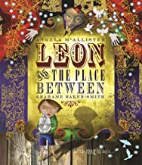 |  |  | Cosmic – Cottrell Boyce  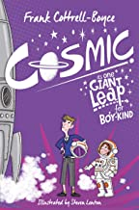 |  |  |  | Until I met Dudley – McGough and Rosen  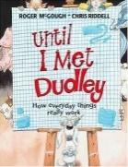  Film Clip – Snoozatron (to learn about explanations)  Picture of a rocket from ‘A Grand Day Out’  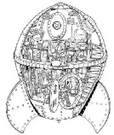  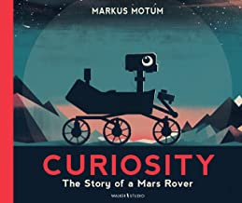  Curiosity – The Story of the Mars Rover – Motum
Writing Outcomes | -Description of the Iron Man toppling off the mountain  -Writing in role as Hogarth’s father  -Iron Man Poem – pupils produce own version |  |  |  |  |  | -Narrative - Portal story  Setting description of the circus tent/land on the other side  -Dialogue between the magician and children |  |  | -Space adventure narrative including moon landing/setting description |  |  |  | -Explanation of how to fly a new spaceship/drive the Mars Rover
Focus GAPS | Daily Spellings  Revision of previous learning +  -Select appropriate structure, vocabulary and grammar to describe atmospheric settings.  -Create complex sentences by dropping in a relative clause. Use a range of relative pronouns: who, which, where, whose, when, that.  -Independently, create and punctuate complex sentences using ing opening clauses  -Identify and use commas to indicate parenthesis, e.g. Pass through the door, which had been abandoned for years, and you will reach the field of dreams.  -Show a growing awareness of the historic & social context of their writing eg Shackleton’s letters. This will impact on the level of formality and the register of their sentence structures and language choices. |  |  |  |  |  |  |  |  | Daily Spellings  Revision of previous learning +  -Identify the audience and purpose. Select the appropriate language and structures.  -Demarcate complex sentences using commas, in order to clarify meaning, including those which have relative clauses.  -Identify and use dashes to indicate parenthesis, e.g. in less formal writing: The day was tiring – although we pillaged greatly – so I lay down wearily.  -Use expanded noun phrases to convey information concisely, e.g. Leif Erikson was a respected sailor with a determined and adventurous soul.
 | Week 1 | Week 2 | Week 3 |  | Week 4 |  | Week 5 | Week 6 | Week 7 | Week 8 |  | Week 9 | Week 10 | Week 11 | Week 12 |  | Week 13 | Week 14
 | Summer 1 |  |  |  |  |  |  | Summer 2
Focus Text | 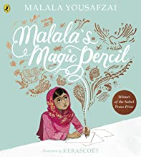  Malala’s Magic Pencil – Yousafzai  Malala – Little People Big Dreams  Children Who Changed the World – Williams  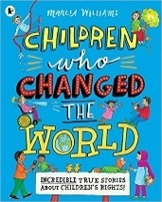 |  |  | The Children of the Benin Kingdom – Orji  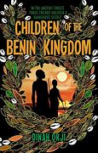 |  |  |  | 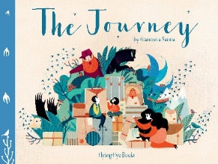  The Journey – Sanna |  |  | The Boy at the Back of the Class – Rauf  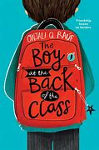
Writing Outcomes | -Biography of Malala |  |  | -First person narrative in role as Ada  -Writing in role as Madu – first impressions of Edo city and the Ogiso |  |  |  | -Writing in role to recount the journey |  |  | -Diary of Ahmed’s first day -Persuasive formal letter about letting refugees to come into school/Manchester
Focus GAPS | Daily Spellings  Revision of previous learning +  -Assess the effectiveness of own and others’ writing in relation to audience and purpose, suggesting changes to grammar, vocabulary and punctuation to enhance effects and clarify meaning with a growing awareness of formality and register.  -With growing confidence use devices to build cohesion between paragraphs.  -Revise the different sentence structures, e.g. simple sentences for clarity or impact, compound sentences to link ideas, complex sentences with a range of openers. Discuss effects created. Using own writing, experiment with different effects by changing sentence types and structures  -Create and punctuate complex sentences using ed and ing opening clauses in fiction and non-fiction writing,  -Using relative pronouns (who, which, where, whose, when, that) to create complex sentences by using relative clauses, both at the end of sentences and embedded within, e.g. The saddened child watched her father, who was waiting for the train. The father, who was waiting for the train, looked down at his daughter sadly. |  |  |  |  |  |  | Daily Spellings  Revision of previous learning +  -With growing independence, chose appropriate structure, sentence structure and language to respond to the context, purpose and audience of the text.  -Create complex sentences where the relative pronoun is omitted e.g. The soothsayer standing at the summit of the pyramid, pondered the moments ahead.  -Blend action, dialogue and description within and across paragraphs.  -Explore the importance of synonyms and antonyms through reading and writing.

