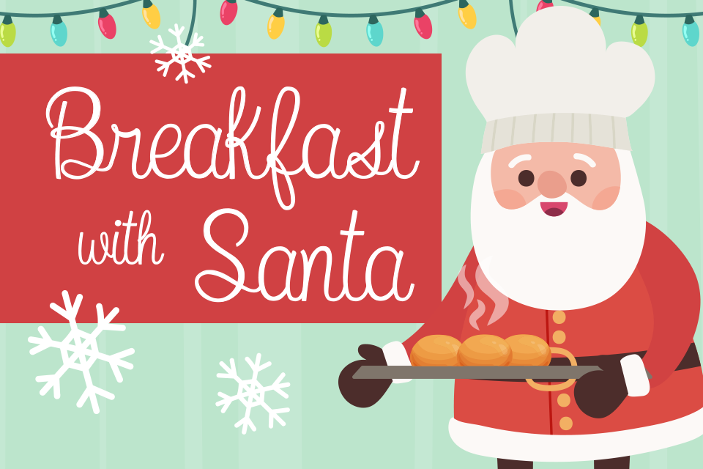
Dear Parents and Carers,
The PTA are pleased to announce that we will be holding Breakfast with Santa events in December. Breakfast with Santa will take place in year groups, each year group will have a different day for their breakfast.
The breakfast will start at 8.15am and after the event children will be taken to their class for their usual day (unfortunately parents will not be able to stay).
Tickets cost £3.00 and children will receive a gift from Santa and a delicious breakfast. Santa will also read the children a Christmas story on his visit.
Thursday 8th December- Nursery @8.15am
Friday 9th December- Reception @ 8.15am
Monday 12th December – Year 1 @8.15am
Tuesday 13th December- Year 2 @8.15am
If you would like your child to attend, please put £3 in an envelope with your child’s name on, their class and write Breakfast with Santa on the envelope then send it into school.
Please send in the money before Monday 5th December so we can cater and plan correctly for the event!
Thank you for your continued support,
Mount Carmel PTA

