05/12/2022

Dear RD Parents and Carers,

This week will be Mrs Dale’s last week with us before she goes on maternity leave. When we come back in January, the class will be taught by Mrs Coogan, she is an experienced teacher who has worked in school before and knows the children.

I’m sure that you would want to join me in wishing Mrs Dale well, as she and Mr Dale await the arrival of their baby at Christmas. What an exciting time it is for their family and we can’t wait to see them all once it arrives.

Meanwhile, thank you for your support as always,

Best wishes,

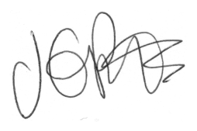

Jacqui Potts
Head teacher

