30th April, 2024

Dear Parents/Carer,

In 2020, Relationships Education and Health Education became statutory for all primary schools in England and as a Catholic school, our mission is to support the spiritual, moral, social and cultural development of all of our pupils, rooted in the wisdom and teaching of the Church.

The education of children in human sexuality is an important, precious and privileged responsibility. The Church teaches us that this is very much a partnership with parents, in which parents are the ‘first educators’ of their children on these matters; ultimately, you confer on us the right to co-educate your children with you.

Mount Carmel has used, ‘Ten: Ten -The Life to the Full programme’ for the past two years. Yesterday’s workshop aimed to refresh parent’s knowledge on the scheme and share with you the RSE curriculum that will be delivered to the children in the summer term and next year.

Following the Parent Workshop yesterday, we would now like to consult with parents regarding the scheme of work and the ‘key decisions’. If you were unable to attend the Parent Workshop, you can still complete the questionnaire; however, it is vital that you complete the online Parent Consultation Course first. If you fail to do this, then you will be unable to give informed responses to the questions.

You can access the Parent Consultation Course by clicking on the following link:

[Parent Consultation Course – Ten Ten Resources](https://www.tentenresources.co.uk/parent-consultation-primary/)

Login details:

Username: mount-carmel-m9

Password: sweet-treats

The parent questionnaire can be accessed on the following link:

<https://forms.gle/9CQF4QBKLfu2dNSH8>

Your feedback is very much valued and we appreciate the time taken to complete the course and answer the questionnaire.

Thank you for your continued support,

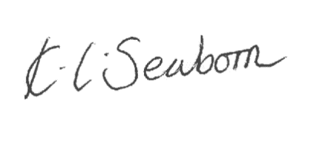

**Headteacher**