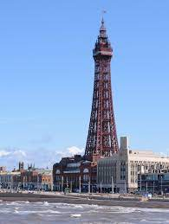Dear Parents/Carer’s, Wednesday 14th May, 2024

**YEAR 1 TRIP TO BLACKPOOL TOWER**

As part of our studies this term, we have arranged a trip to for Year 1 children to go to Blackpool on **Thursday 27th June.**

Whilst in Blackpool, the children will ride to the top of the Blackpool Tower, have a 4D cinema experience, have lunch in the Tower Ballroom and have a walk on the pier.

The coach will depart from school after registration at 9.00a.m. promptly and the children will return to be collected from school at the normal home time.

You can either provide your child with a packed lunch from home, (please provide this in a disposable plastic bag) or you can order a packed lunch provided by Dolce from school. Order forms for school packed lunches will be sent home nearer the time. The children are to wear school uniform, also please ensure they have sun cream and a sun hat if it is a sunny day and make sure sun cream is applied before they come to school in the morning. Please also make sure they have a raincoat. If your child has an inhaler, please ensure it is brought in on the day, otherwise your child will be unable to go on the trip.

We are asking for a voluntary contribution of **£16.30 per child,** this will cover the cost of transport and entrance to the Tower. If we do not get enough voluntary contributions, we may have to consider cancelling the trip.

If you wish your child to participate in this trip please consent and pay **via ParentPay by Friday 21st June.** If you feel you may experience difficulty with meeting the cost, please contact the Infant school office.

Yours sincerely

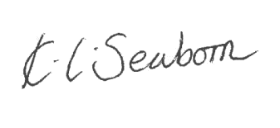

**K. Seaborn**

**Head Teache**