Curriculum Enrichment 2023-2024

Nursery
Asda
Nursery made a visit to their local store, Asda. We took a shopping list to buy some delicious items to make something special back at school – porridge! We learnt that we had to walk safely, away from the road, and that when we crossed, we use the pelican crossing. At Asda, we picked our ingredients, took them to the tills, scanned and payed for them. It was so much fun!
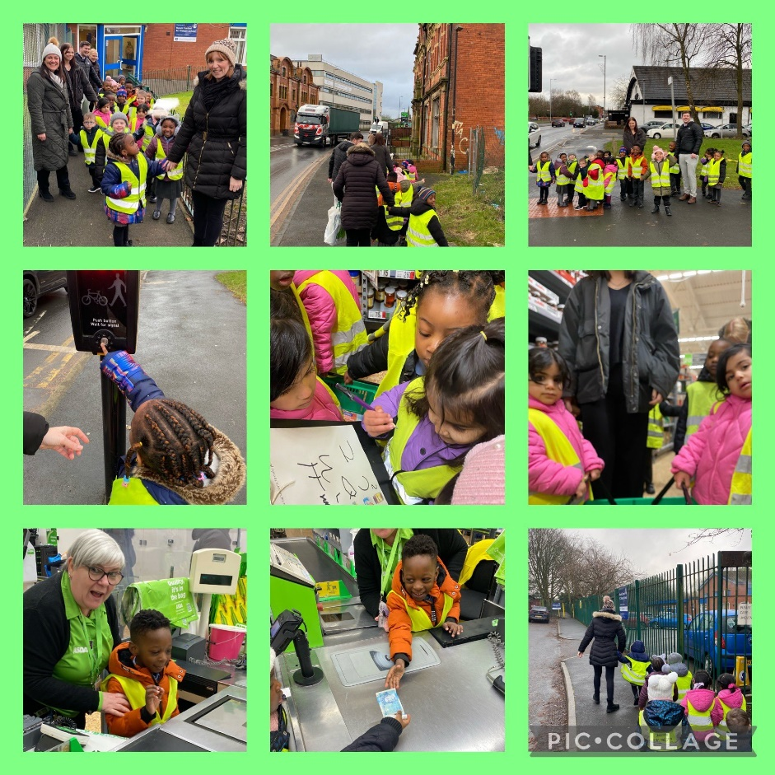
Chinese New Year
Nursery went on a dragon dance around school and wished everyone a very happy Chinese New Year.
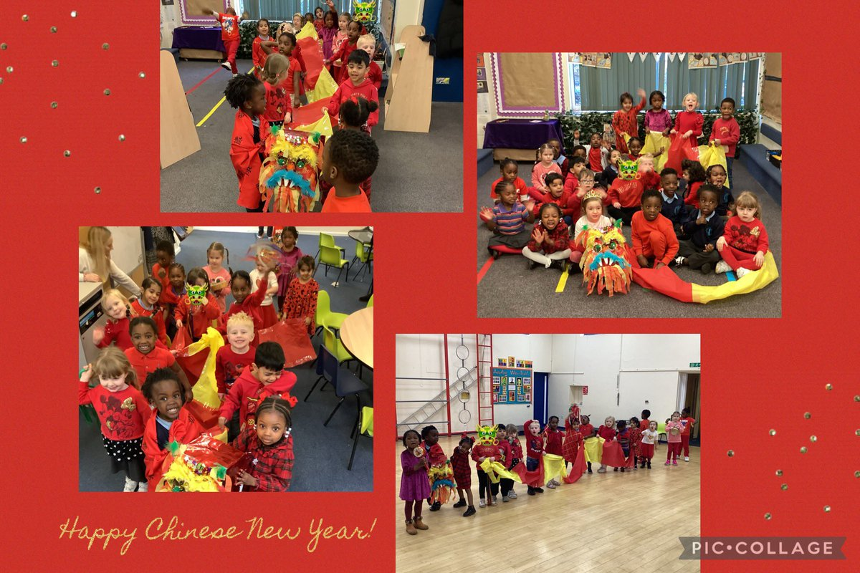

Reception
Nurse Visit
Reception loved having a visit from a nurse for our topic all about People Who Help Us. We got to use real stethoscopes, bandages, syringes and pretend we were in surgery with our masks!
“My favourite part of the activity was using the syringes because it was fun.”
“I learnt about nurses and doctors.”
“I learnt that they use masks to stop germs.”
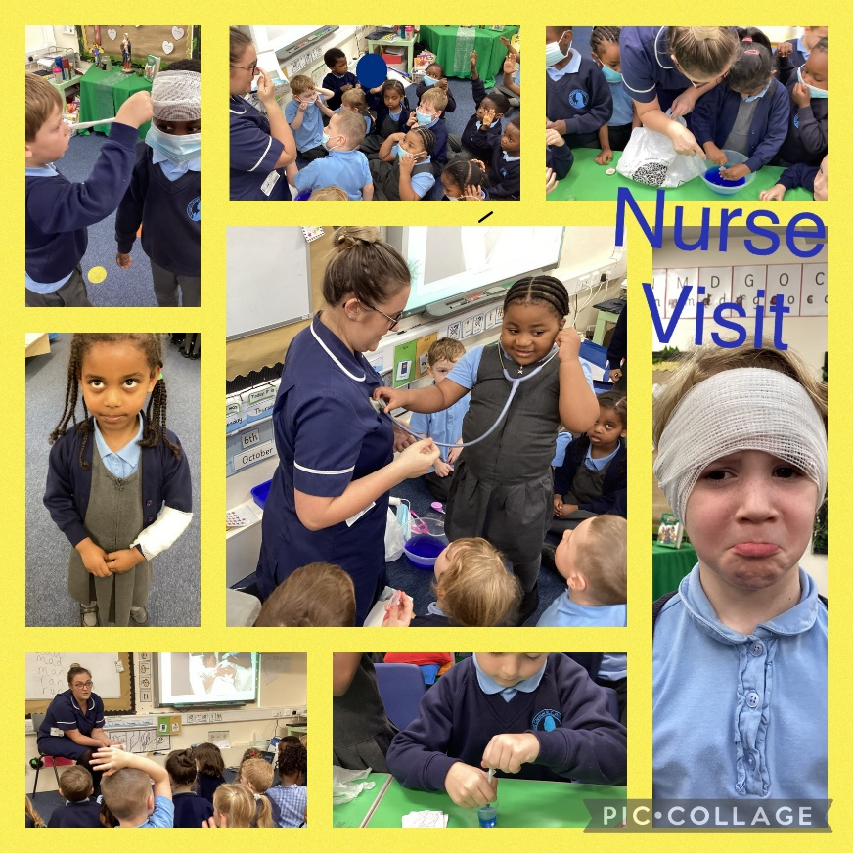
Boggart Hole Clough
The children in Reception enjoyed visiting Boggart Hole Clough looking for Leaf Man. We found lots of autumn leaves and enjoyed making our own leaf men when we got back to class. “Leaf man goes wherever the wind blows”.
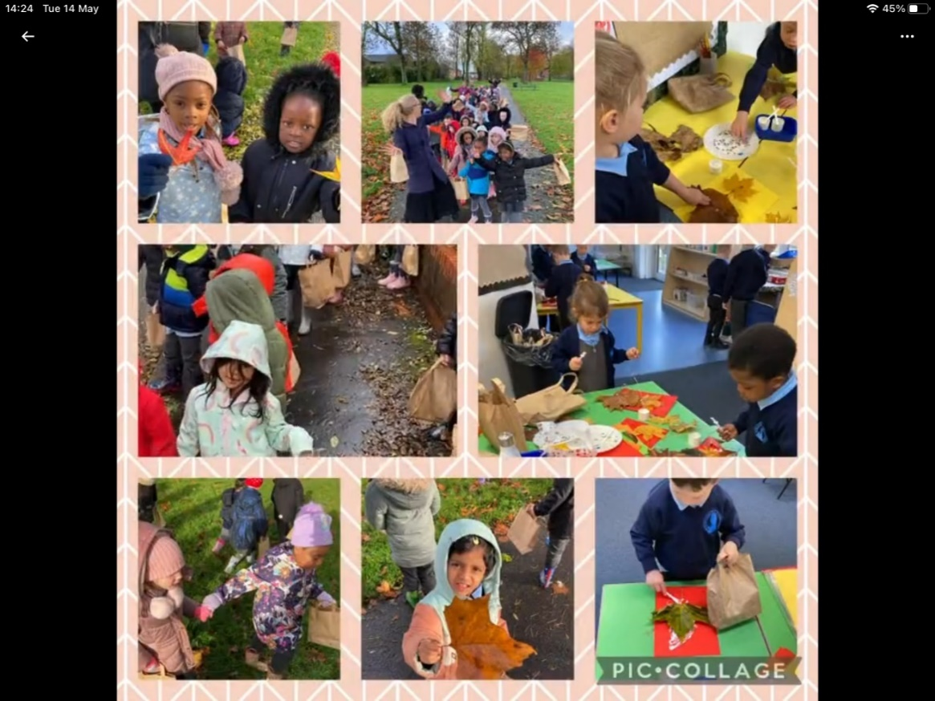
Chinese New Year
Reception loved trying all these Chinese for Chinese New Year! We ate Chinese food, danced to Chinese music and created lots of beautiful Chinese artwork using numbers, dragons and lanterns.
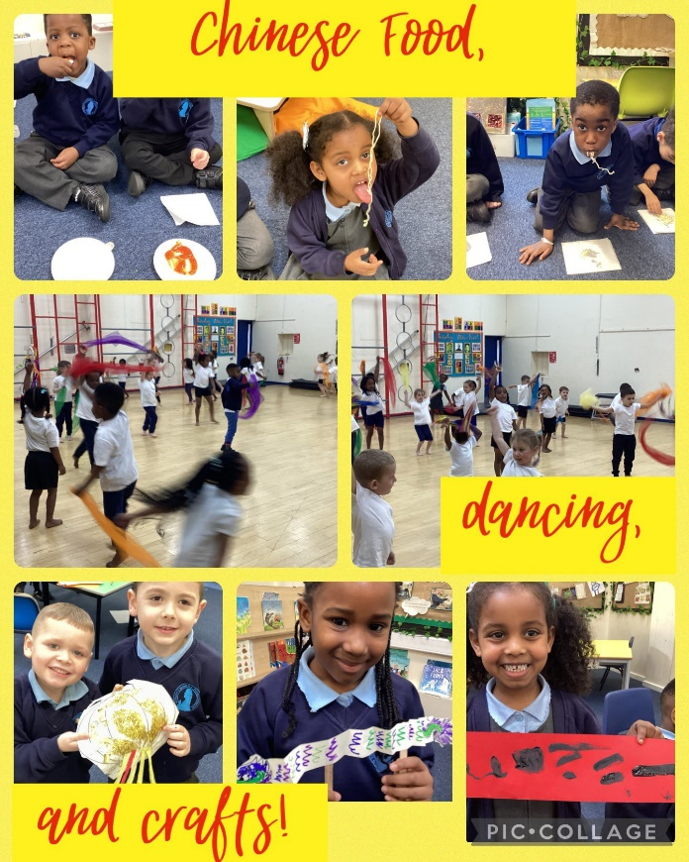
North City Library
Reception enjoyed their trip to North City Library. We learnt that the library is there for us to explore different books and it is an opportunity for us to sit down and read in a quiet, peaceful place. We loved how colourful it was!
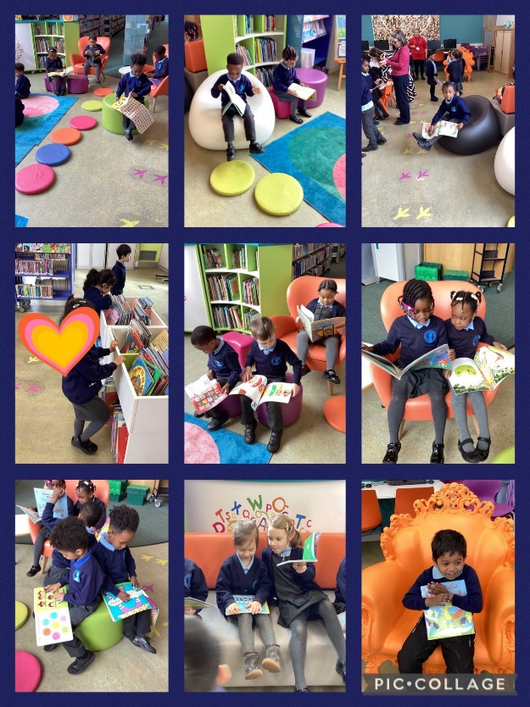
Nature Walk
Reception went on another walk around Boggart Hole Clough, but this time looking for signs of Spring and Summer. We were able to notice the difference in the environment between Autumn and Spring – in Autumn the leaves are brown and in Spring they are green. It was so nice to enjoy the sunshine.
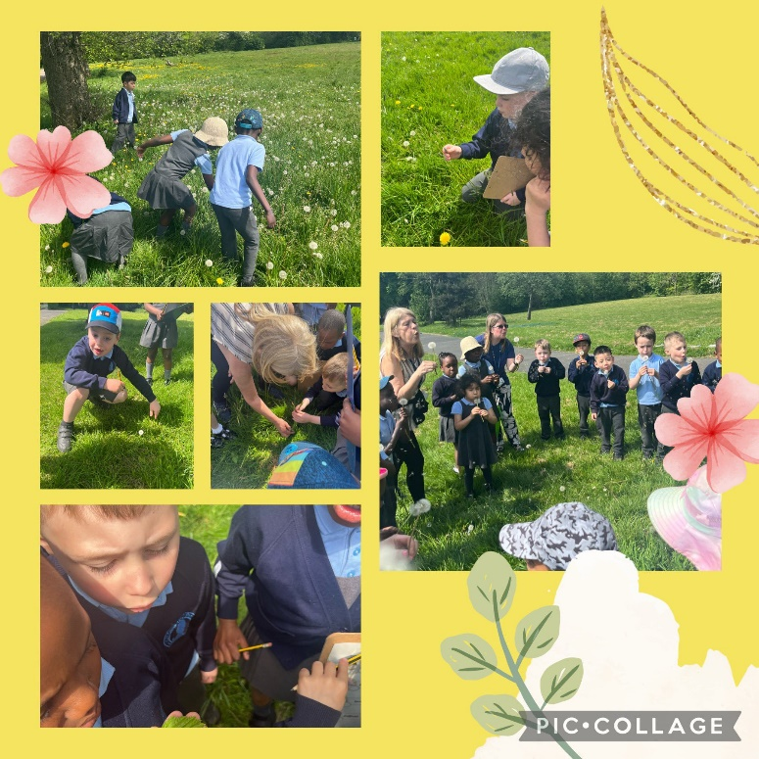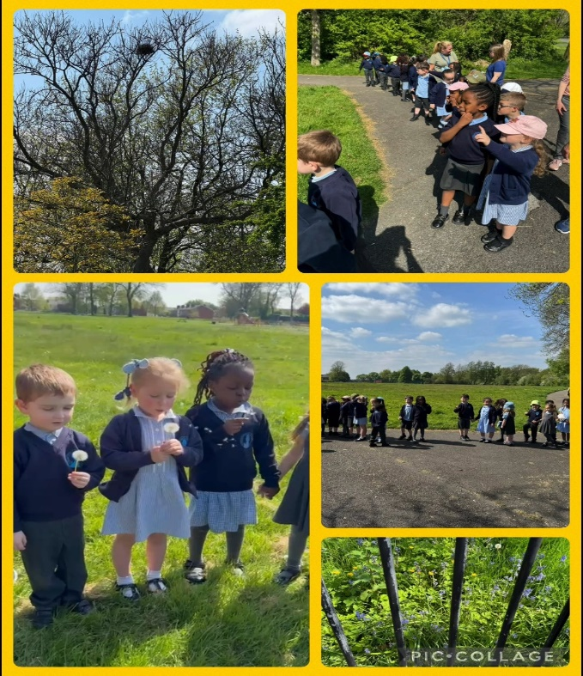
Smithills Farm
The children had a wonderful day when they visited Smithills farm. The children enjoyed a donkey ride, tractor ride, fed lots of animals and had a lovely time holding and stroking the animals. We also saw the farmers using lots of machines to milk the cows which inspired us to have a go at milking cows the old fashioned way. We had to squeeze as hard as we could to milk the cows.
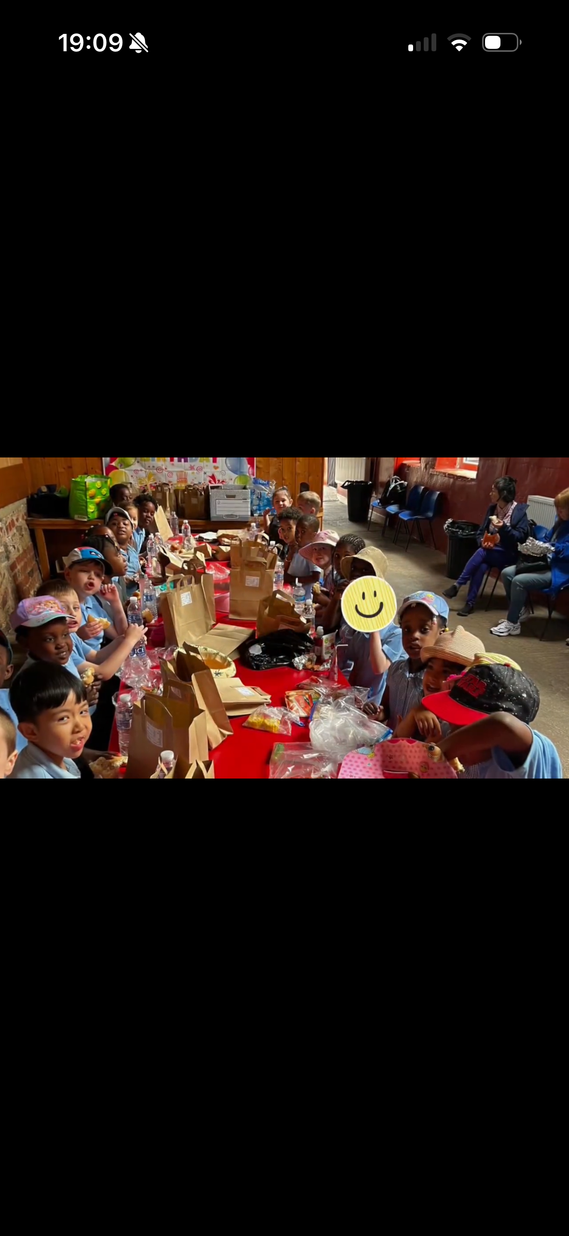
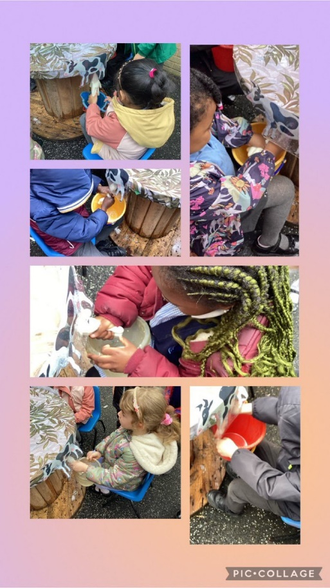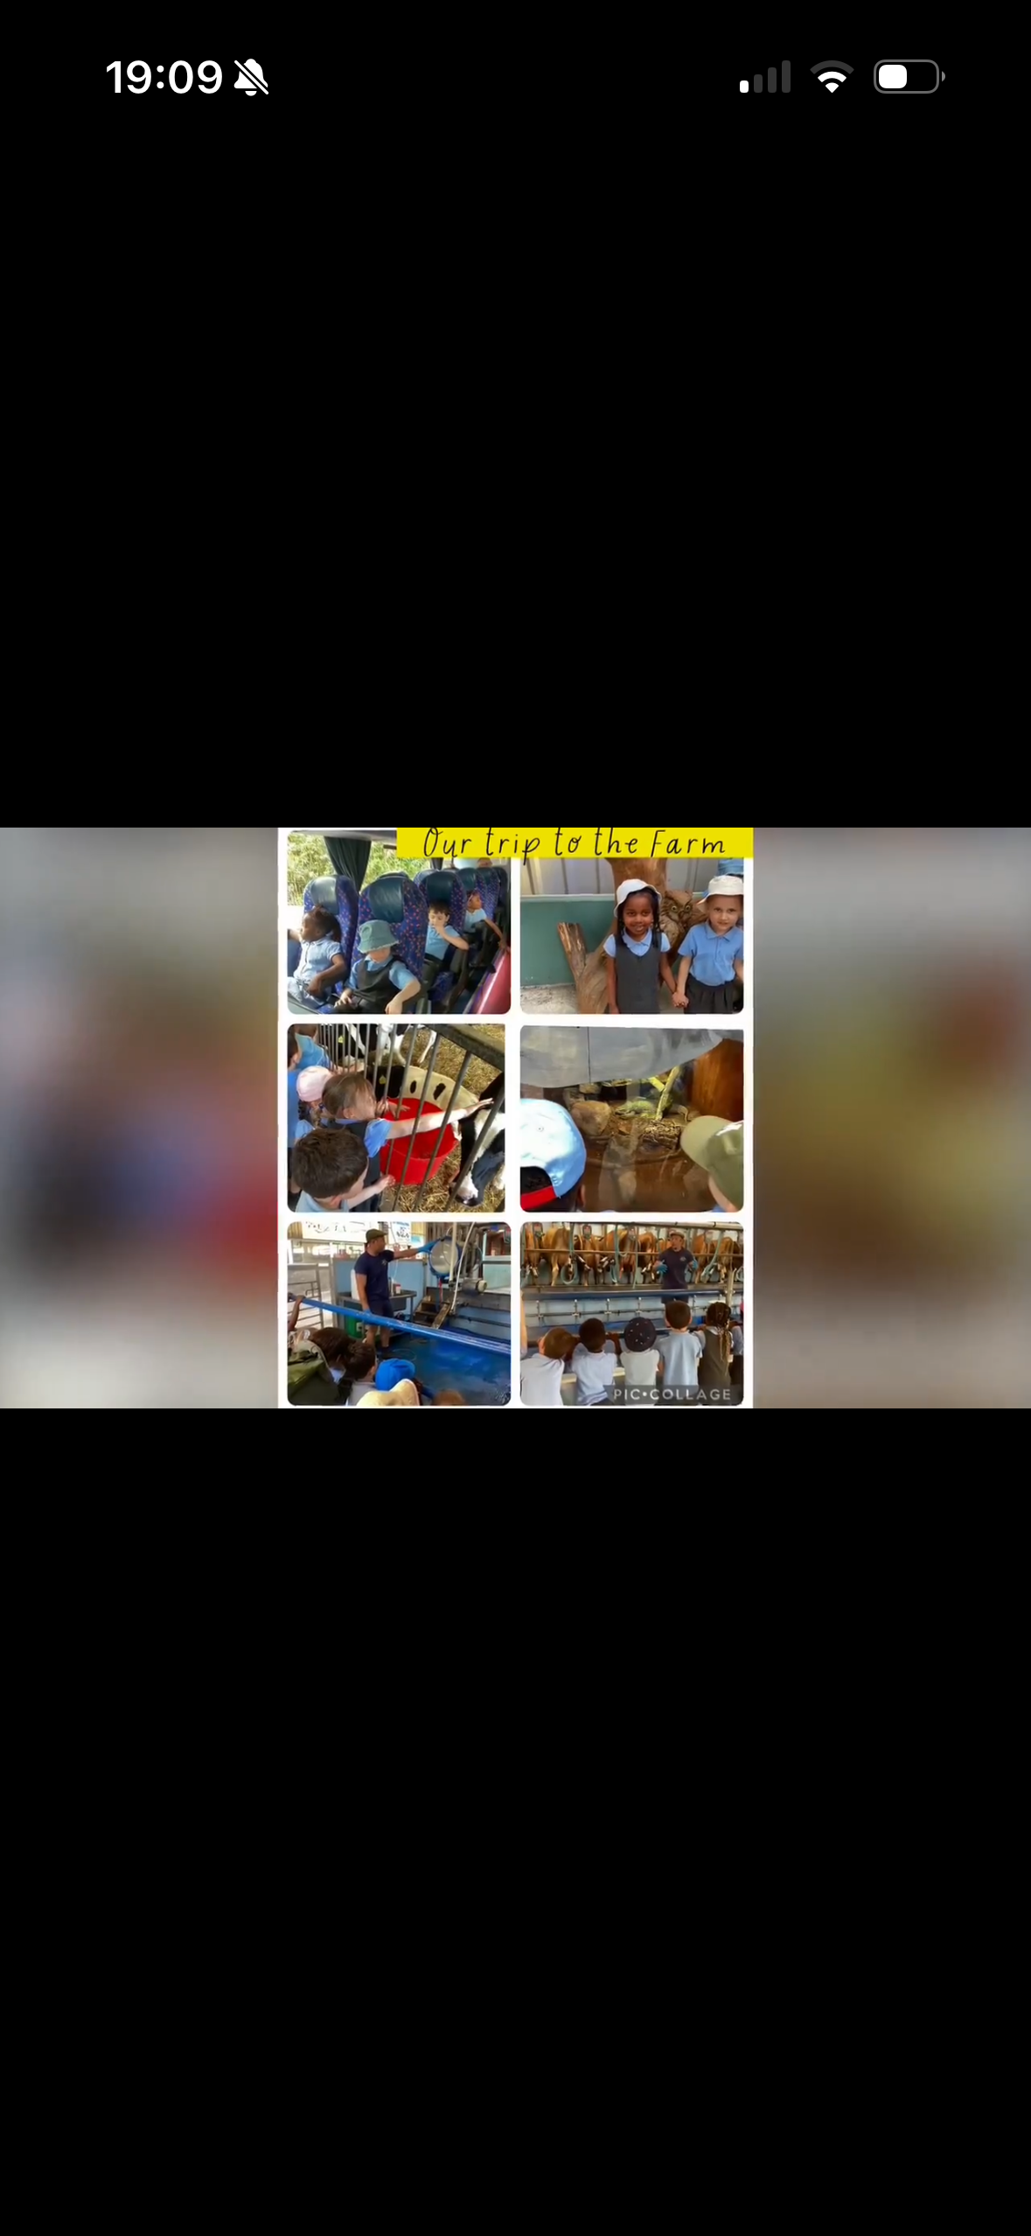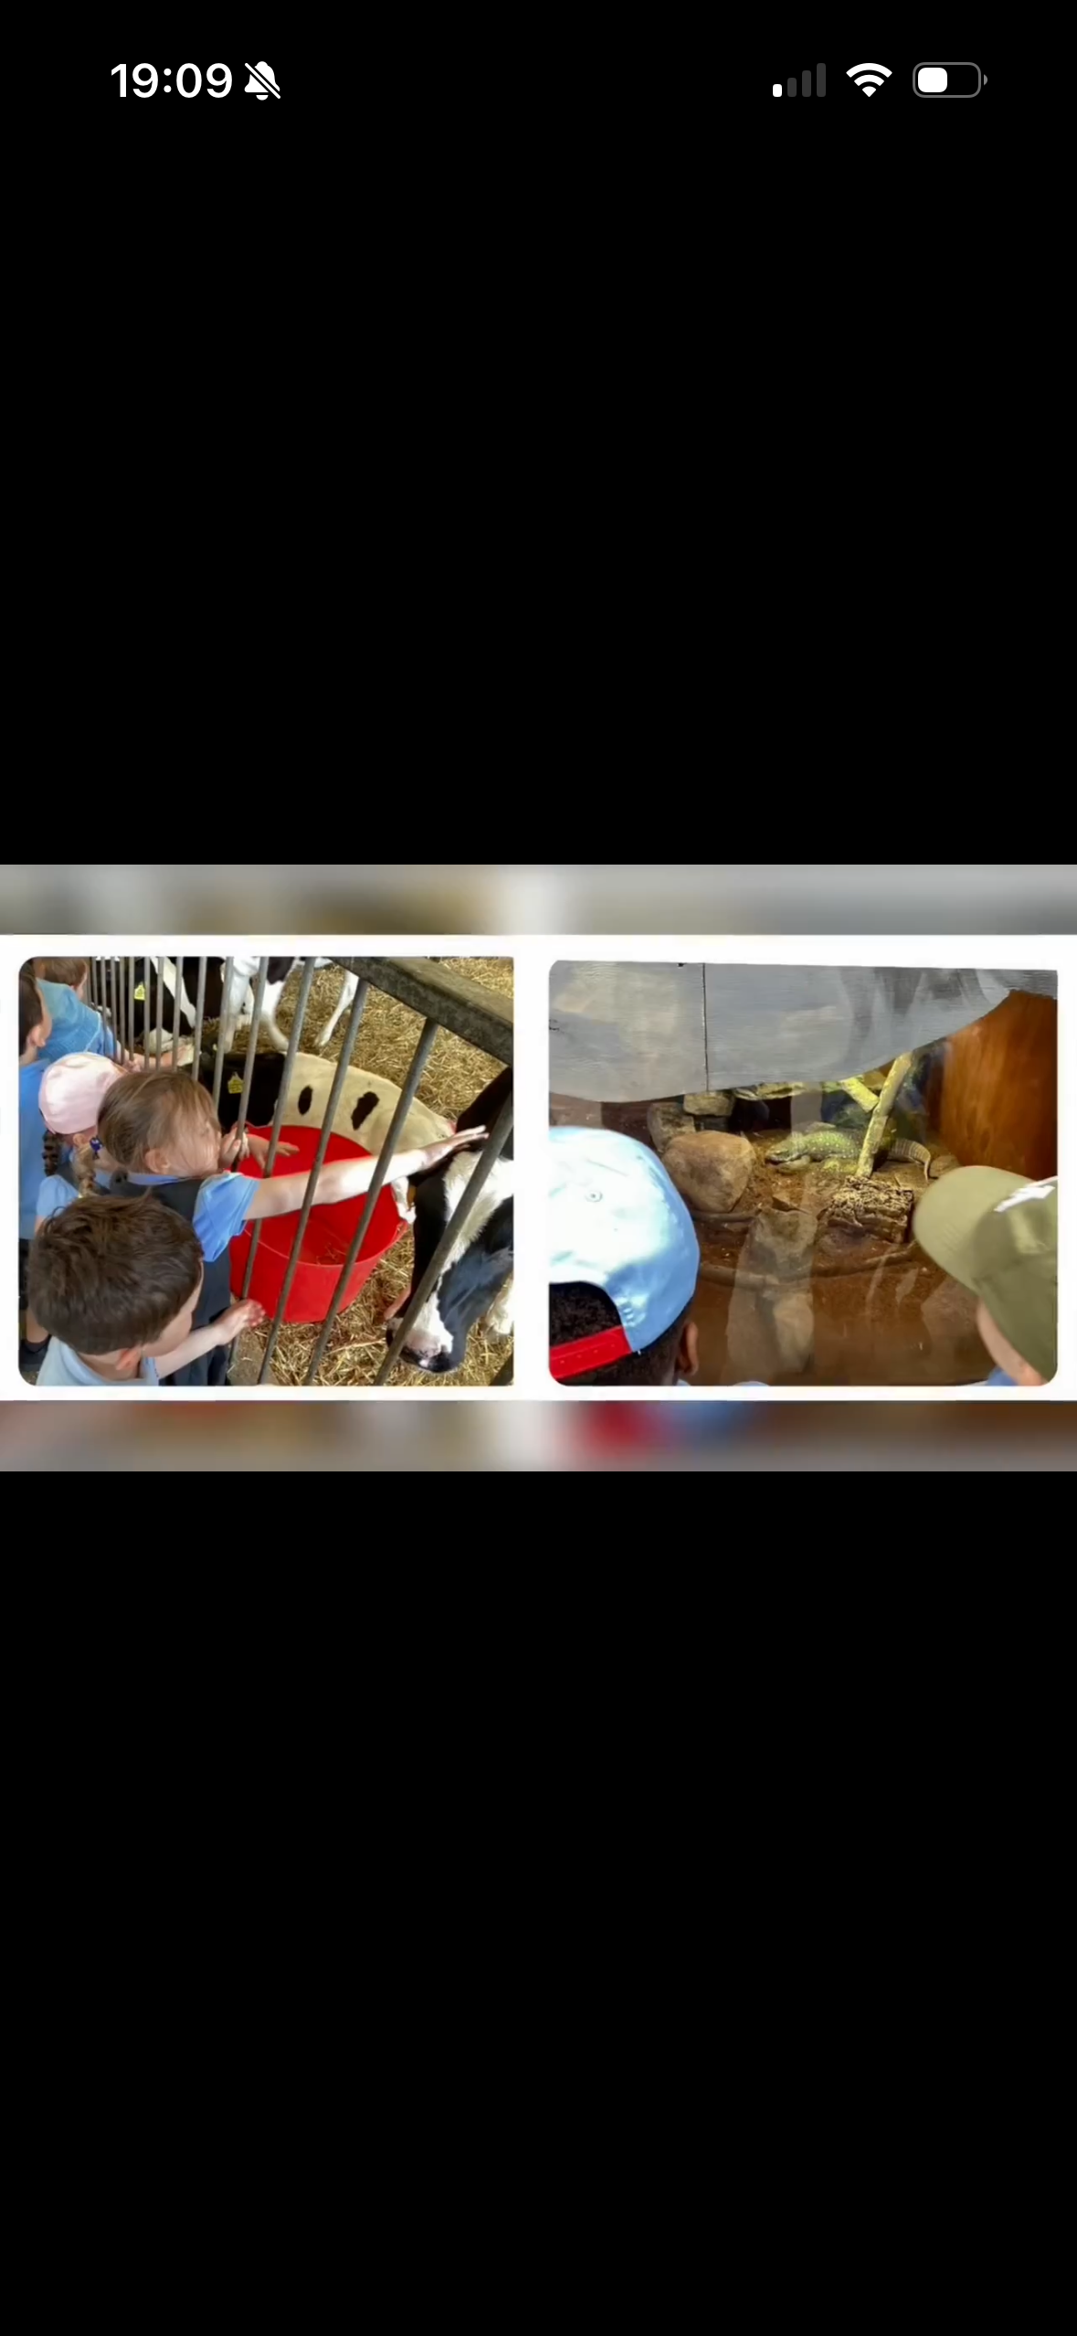

Year 1
Changes Within Living Memory
As part of our history unit, Changes Within Living Memory, we learnt about changes in our local area. We went on a local walk to see how the local area has changed since the 1950s.
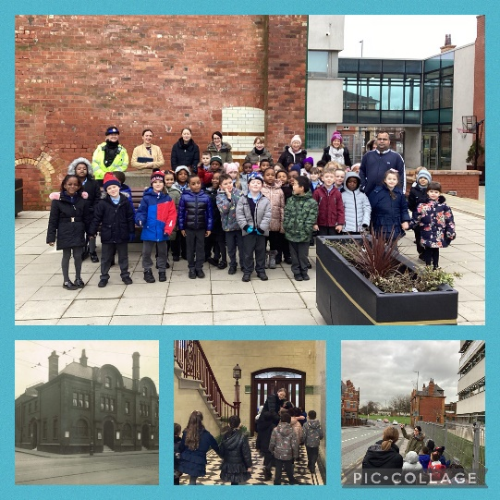
National Festival of Fieldwork
Year 1 explored the local area. We discussed the direction we were walking in and pointed out significant landmarks. When we returned to school, we sketched a map and included the landmarks we saw on our walk.
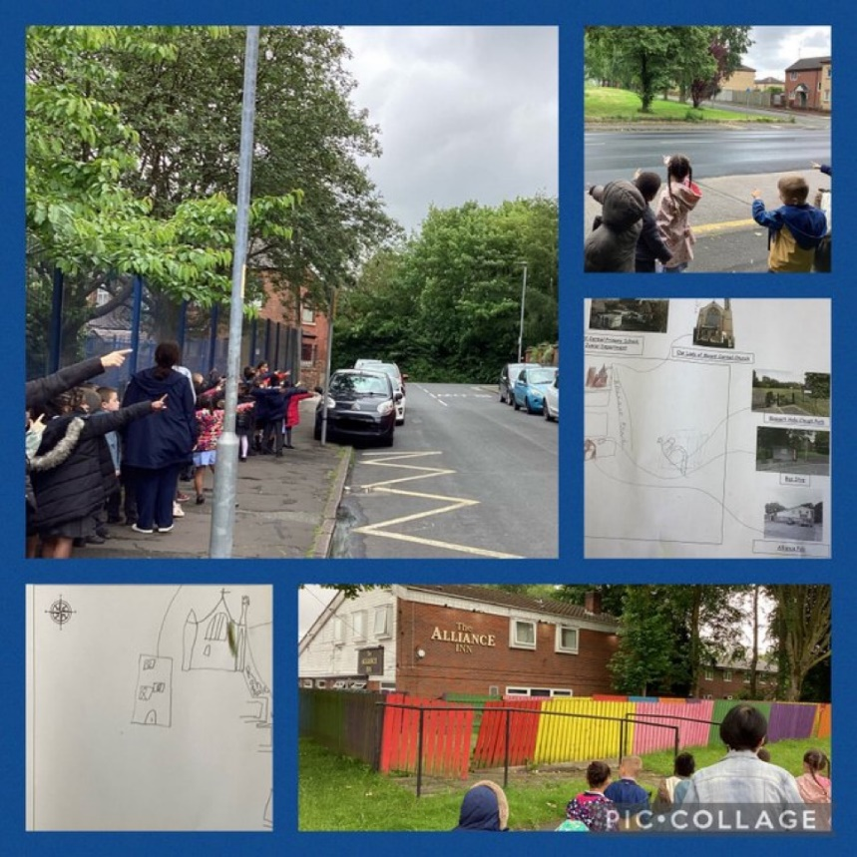
Blackpool
Year 1 had a fabulous time in Blackpool. The children enjoyed spotting seaside features and had a great time in the famous ballroom. We were even lucky enough to visit the Sea Life Centre. Our children can’t stop talking about how much they enjoyed their visit to Blackpool!
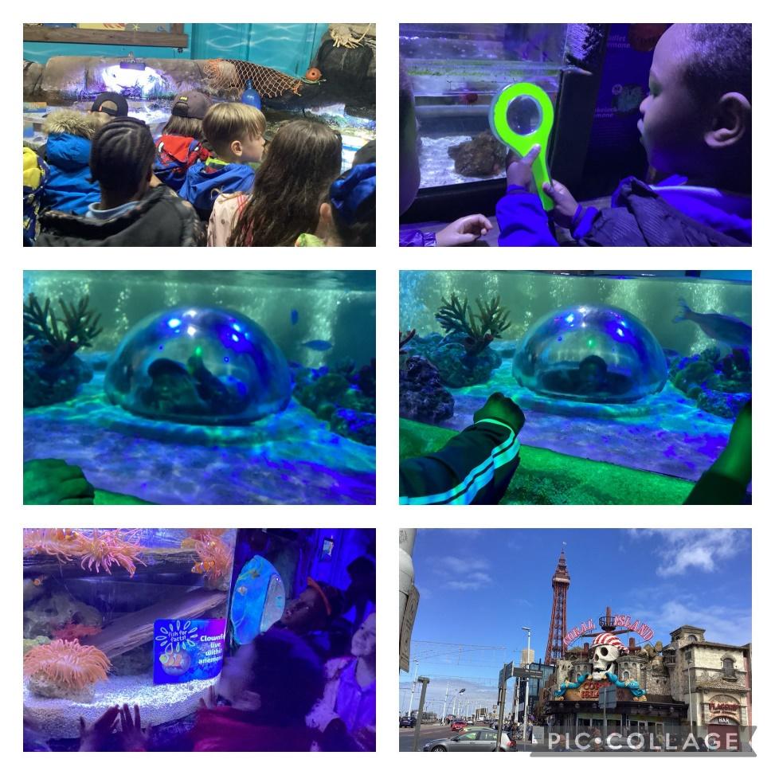

Year 2
War Memorial
As part of our History topic, Remembrance, Year 2 took a trip to the war memorial in our local park. We talked about the poppy wreaths at the memorial and who we remember when we are there. We finished our trip with a prayer to Our Lady.
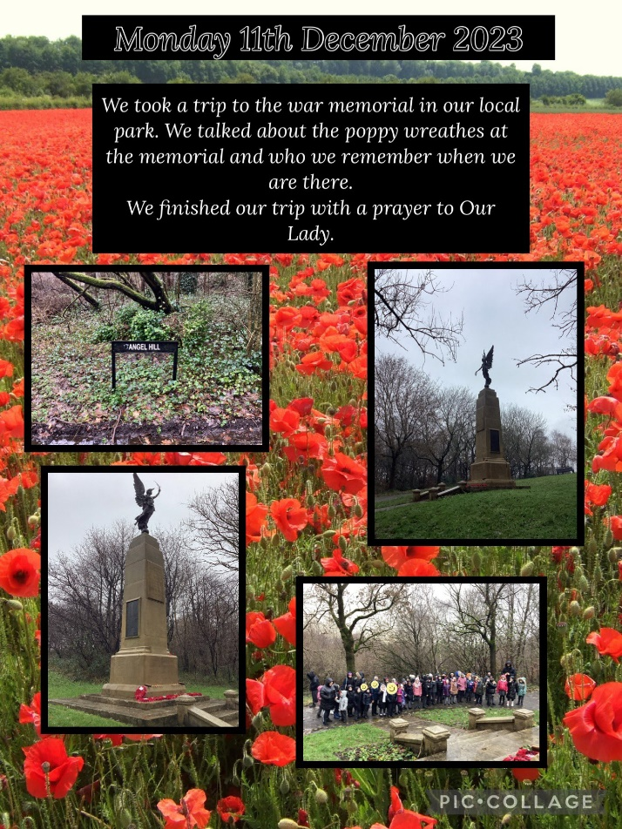
Paul Hamlyn Manchester Project
We are so excited to be part of the Paul Hamlyn Manchester Project. Year 2 used GarageBand to create our own music using the keyboard with chords and arpeggios. We even got to use our own voices and creative sounds with the sampling tool.
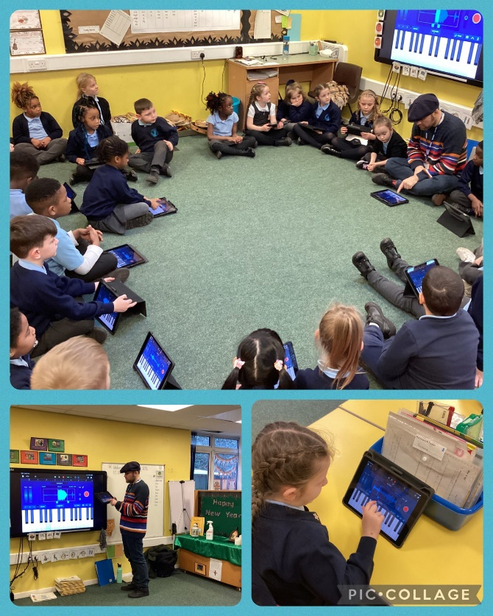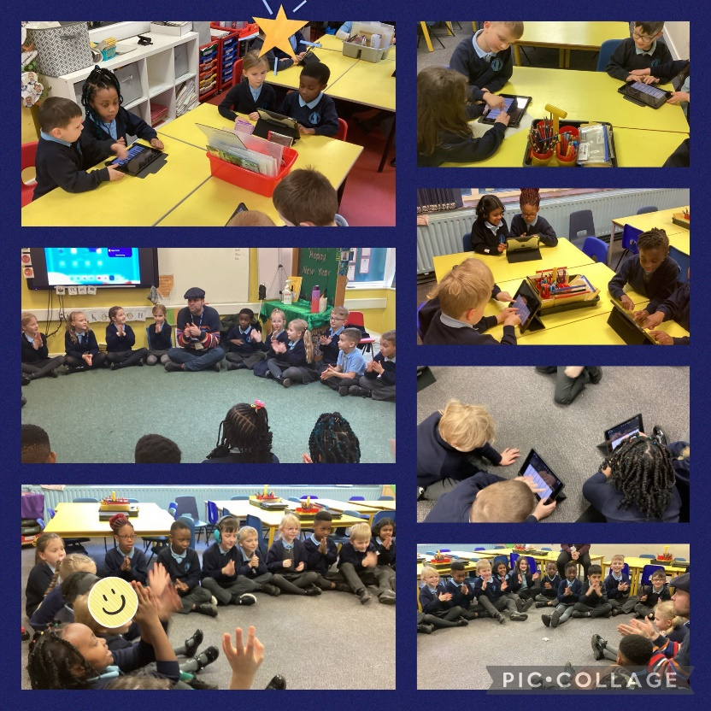
Manchester Fire
Year 2 had a special visit today from Steve and Paul from Greater Manchester Fire and Rescue Service. They talked to us about safety in the home and the importance of smoke alarms. They even showed us the fire engine parked outside!
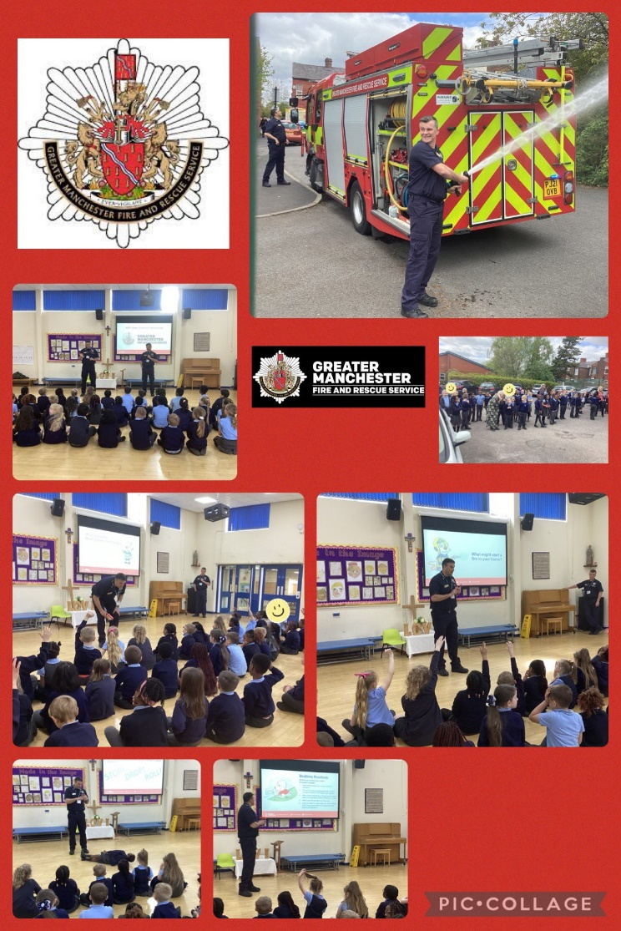
MOSI
Year 2 went on a trip to the Science and Industry museum in Manchester. The children had a wonderful day exploring the textiles gallery, the experiment gallery and finally listening to the Revolution Manchester show.
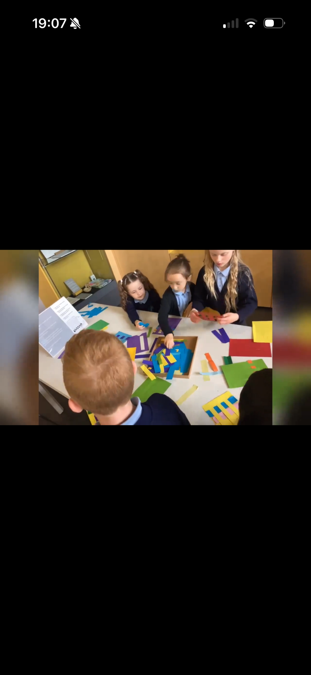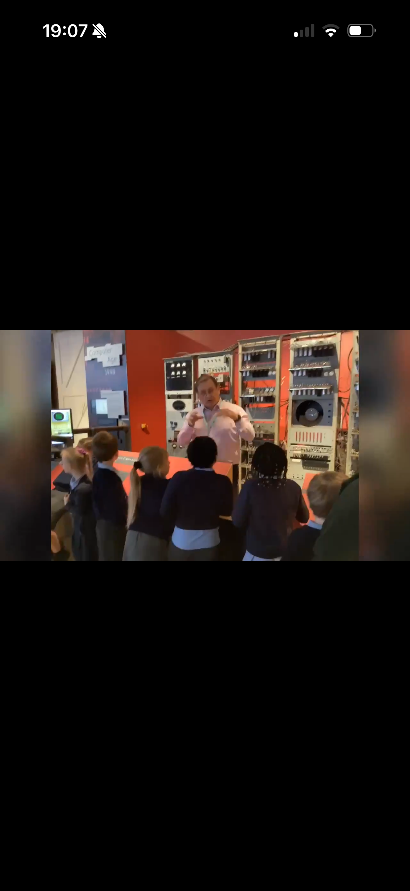
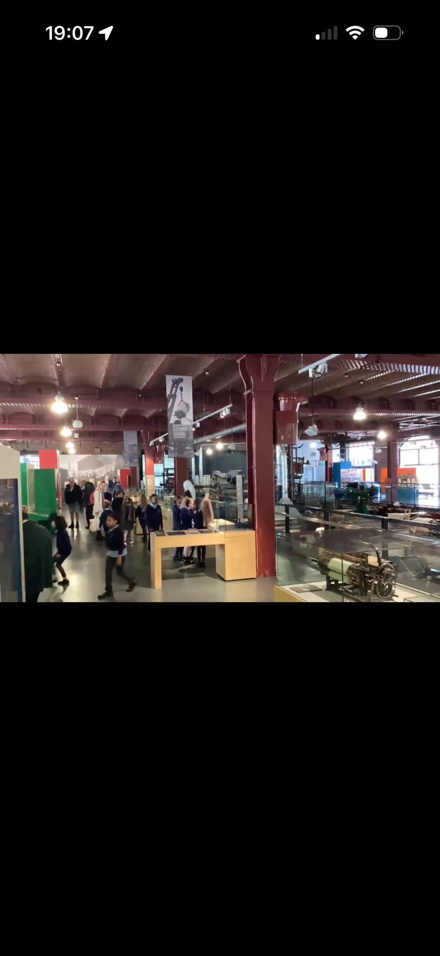
NatWest
Year 2 had a special visit from the NatWest Bank to help us to learn about money and helping us to think about the difference between needs and wants. Thank you, we learnt so much!
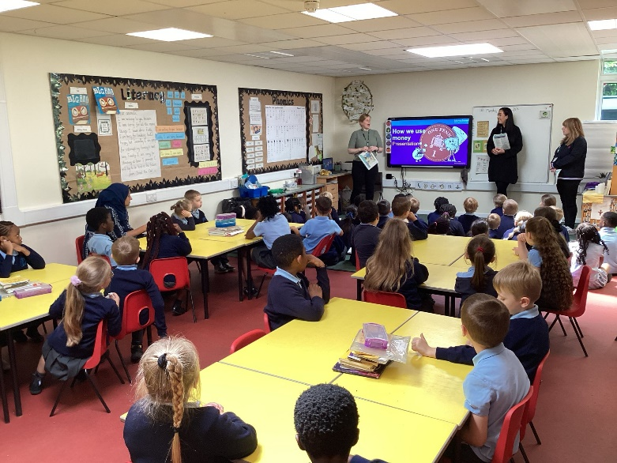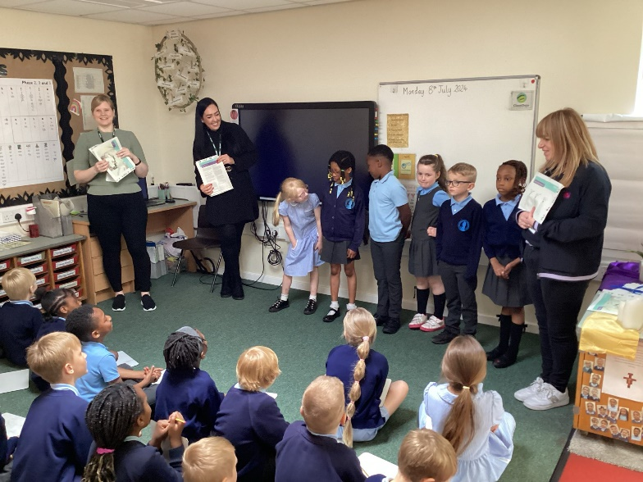
Mrs Wilson
Year 2 were so lucky to have a special visitor, Mrs Wilson, come in and speak to them. She came to us to tell us all about her visit to see Pope John Paul II in Heaton Park in 1982. The children had lots of interesting questions and she showed the children some great keepsakes of the special day.
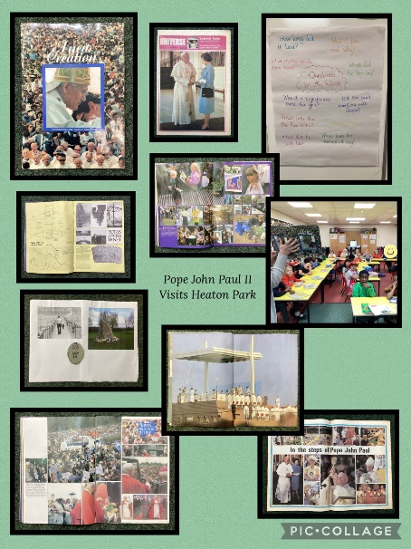

Year 3
Pizza Express
Year 3 took a trip into Manchester on the bus to visit Pizza Express. We washed our hands, put on an apron and learnt from the professionals about how to make a pizza. We learnt what the main ingredients were to make the pizza dough, spread on the tomato sauce, and topped it with cheese and dried oregano. Whilst the pizzas were cooking, we learnt that pizza actually originated from Egypt(!!) and we also learnt about all about the origins of the main ingredients. When the pizzas were cooked, we sat outside in front of the fountains and enjoyed the fruits of our labour. We then took a small tour around Manchester to see the famous landmarks, such as The Urbis (Manchester Football Museum), Manchester Cathedral and Manchester Arndale; this will help us in our Art topic next half term.
“My favourite part of the trip was when we got our aprons on and flipped the pizza!”
“I enjoyed flipping the pizza dough because it was fun to watch it go up into the air and try to catch it to practice being a chef.”
“One of the things I learnt on this trip was that the bee symbol is the symbol of Manchester and shows we work hard.”
“My least favourite part of the trip was when it was over!”
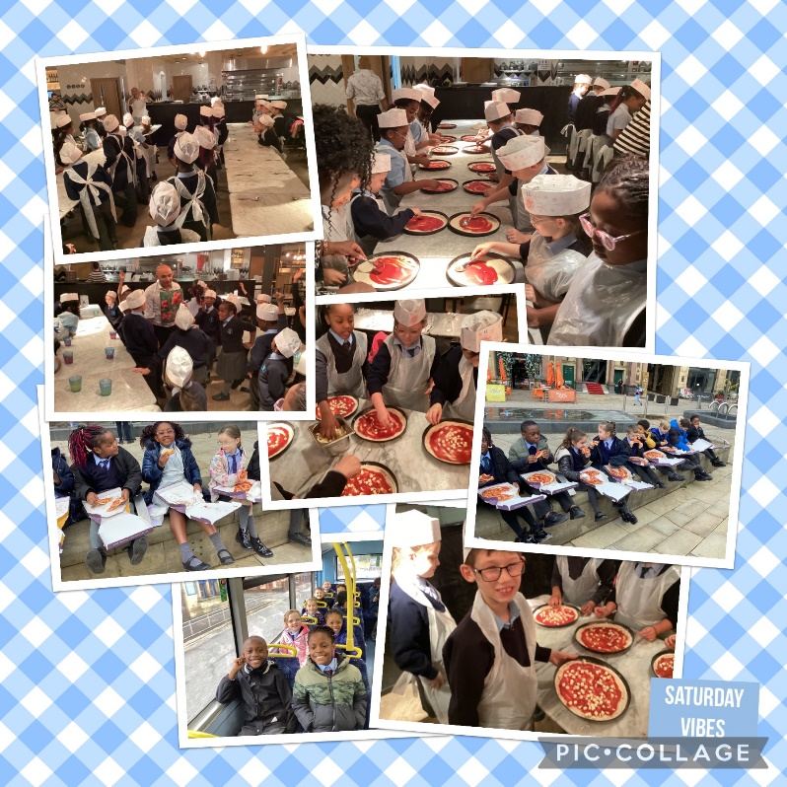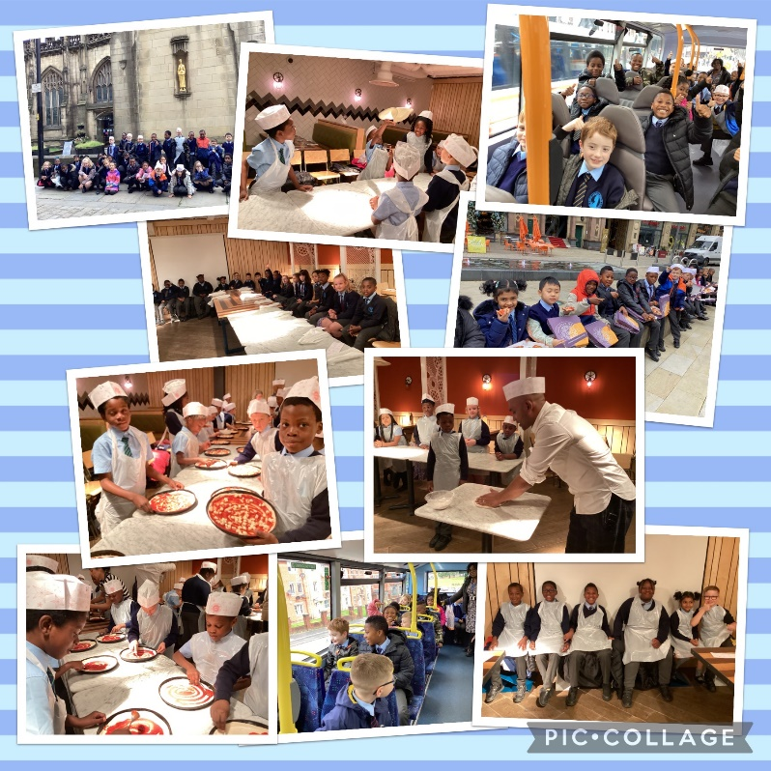
Manchester Central Library
Year 3 had a fantastic visit to Manchester Central Library to celebrate World Book Day. We met the very talented Nick Sharratt, who read two of his books to us, and taught us how to draw Mr Pope, a unicorn and a dragon. We loved it!
“My favourite part of the trip was meeting an author in person.”
“I got to talk to Nick at the end!”
“I high fived Nick Sharratt!”
“I was so excited when my drawing was shown on the big screen.”
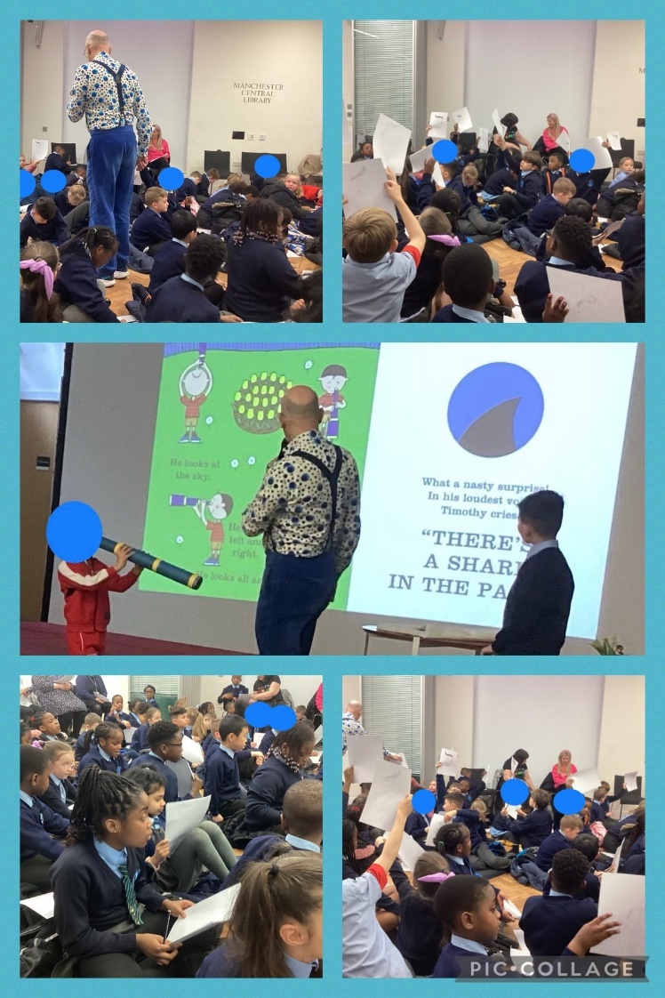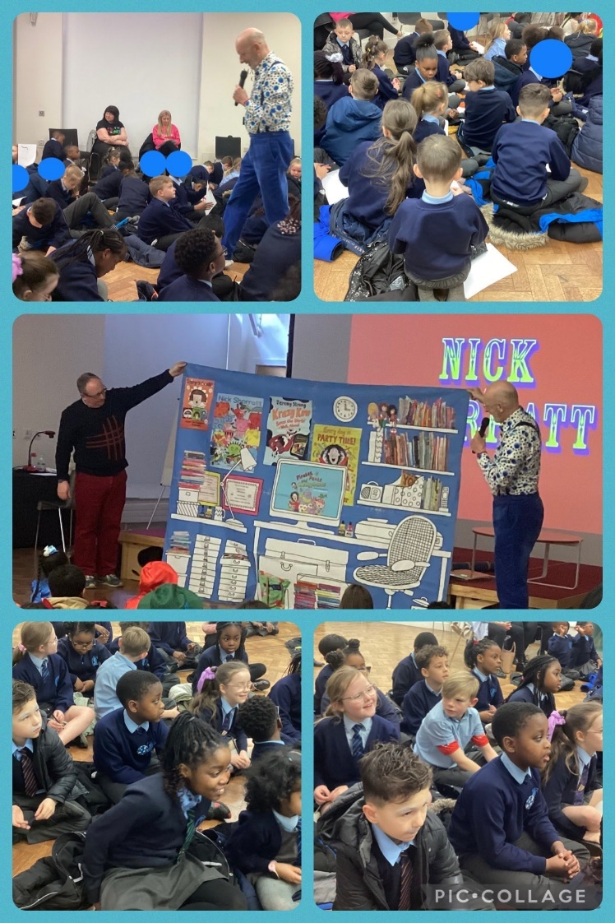
Jewish Museum
Year 3 had an amazing time at the Jewish Museum. We went into the Synagogue to see the Ark, the Torah Scrolls and the Eternal Light. We looked at the stained-glass windows and how they told the story of Moses, and we looked at different artefacts such as the Tallit, Kippah and yad. We also learnt why Jewish people had migrated to Manchester.
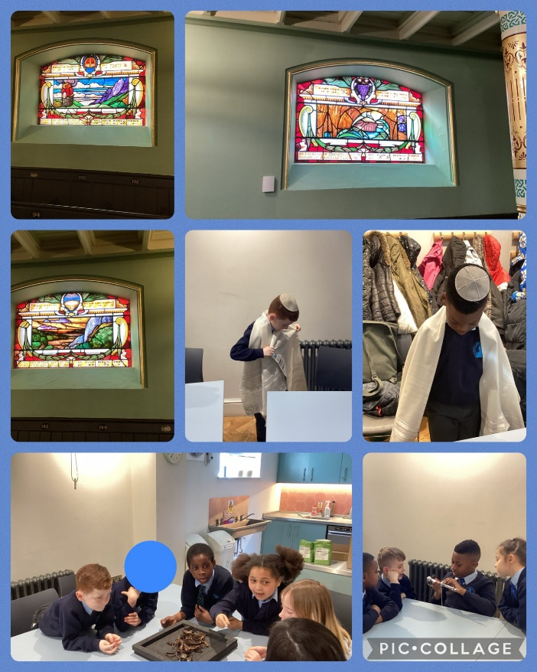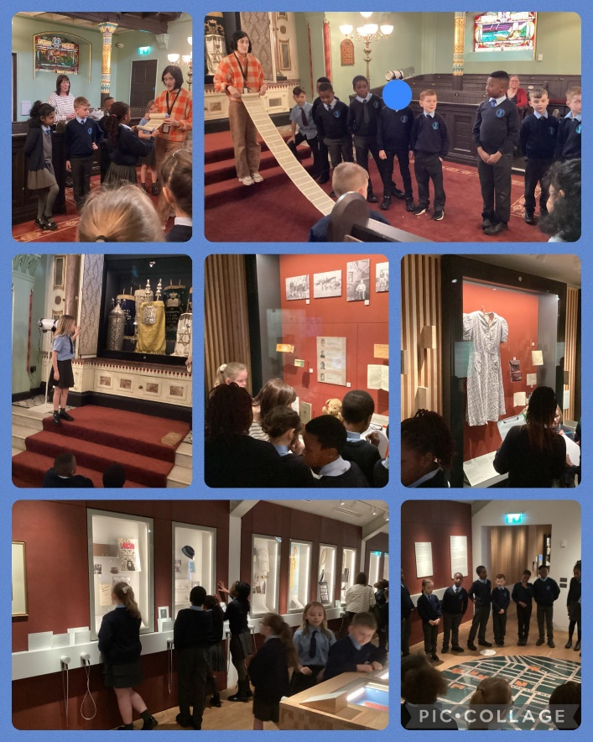
Paul Hamlyn Project
Year 3 had lots of fun working with Kris on GarageBand to create our own pieces of music as part of our Paul Hamlyn
Project.
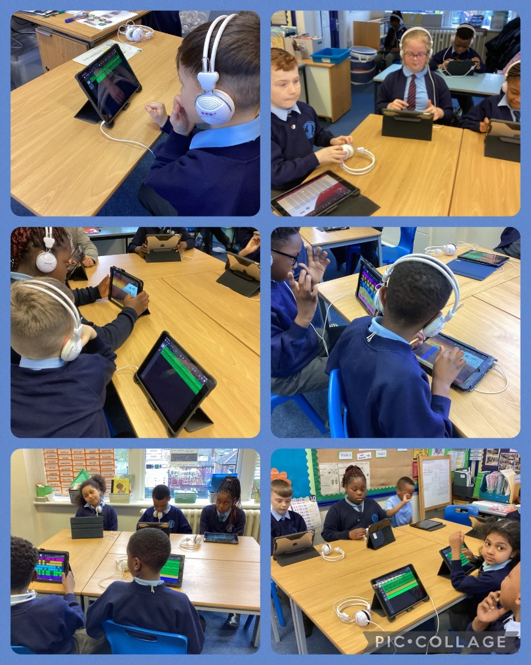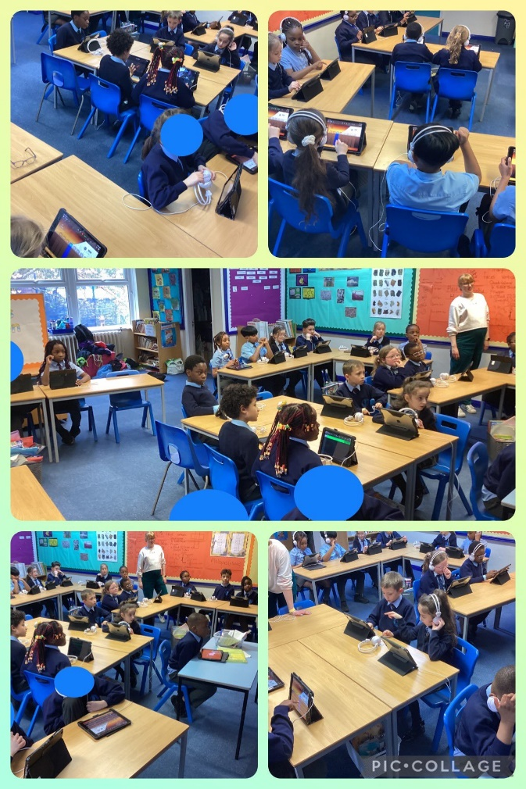
Ancient Egypt
Year 3 were really excited for their Ancient Egypt day. To start the day, they travelled to the land of Ancient Egypt and helped Aari the Scribe to mummify a body. We then moved onto different activities in the classroom. One activity was to design a city from Ancient Egypt and the other activity was to investigate different Ancient Egyptian artefacts. In the afternoon, we learnt how to become scribes like Aari, using hieroglyphs, real papyrus paper, reed pens and real Ancient Egyptian ink. We then played Ancient Egyptian games called Mancala and Senet.
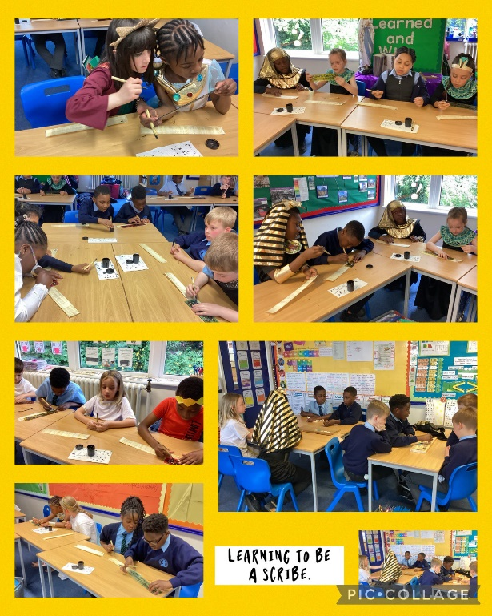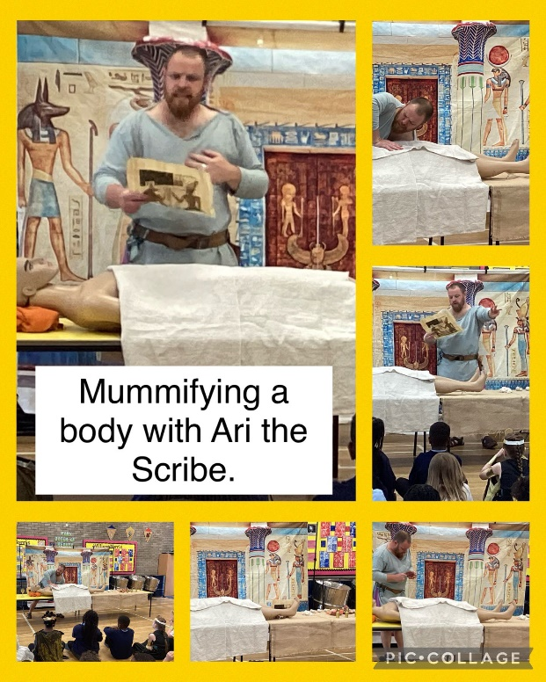
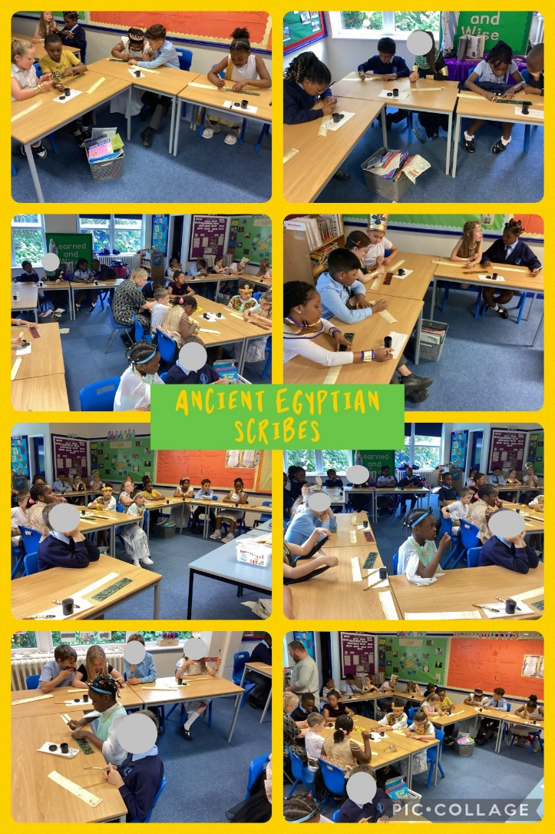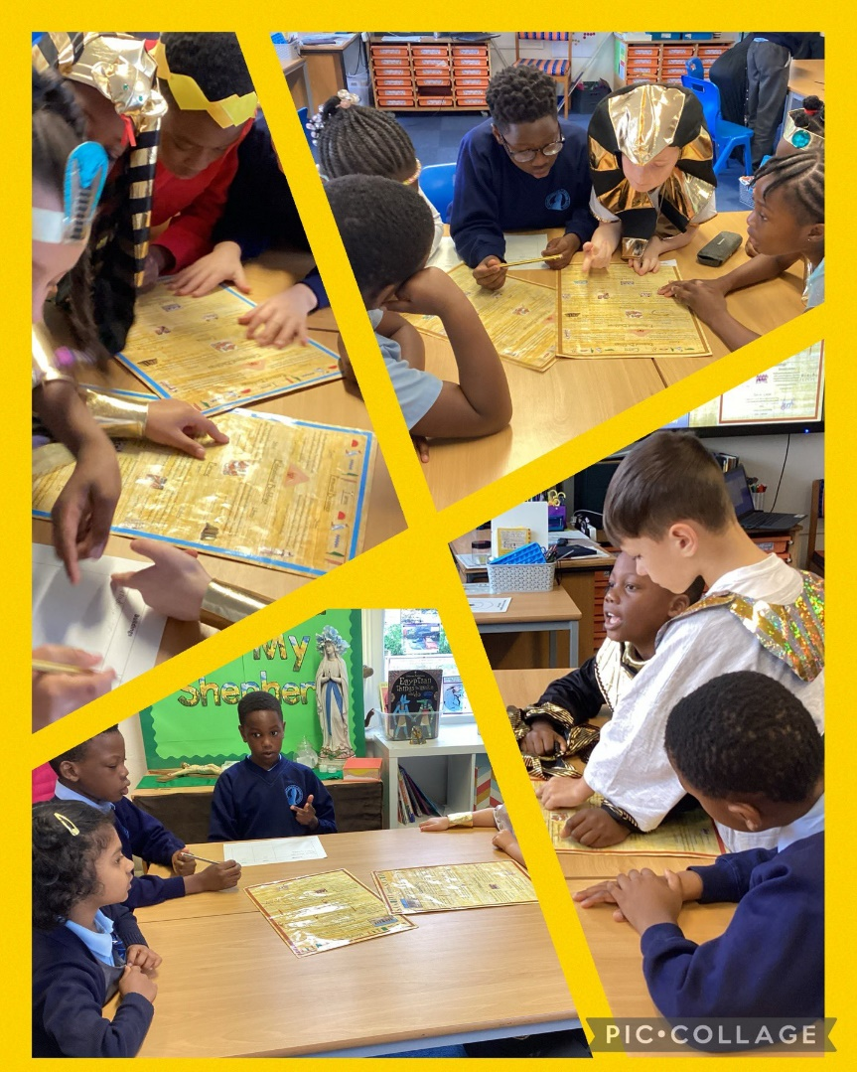

Year 4
Electricity Workshop
Year 4 had a special visitor, Stephen, from Creative Builders Workshop, learning all about electricity through Lego. We learnt: where electricity comes from, the difference between a complete and incomplete circuit, how a switch works and why they are needed, how to construct a simple series electrical circuit and identifying and naming its base parts.
“This workshop was really fun and we also learnt things at the same time.”
“I learnt what a circuit is and I also know what crocodile clips are.”
“I really enjoyed it and I was proud because my Lego lit up on the first try.”
“My least favourite part of the activity was taking it apart. I disliked this part because the activity was finishing.”
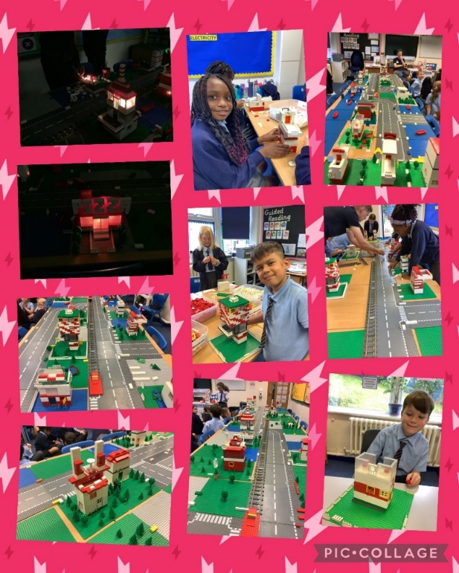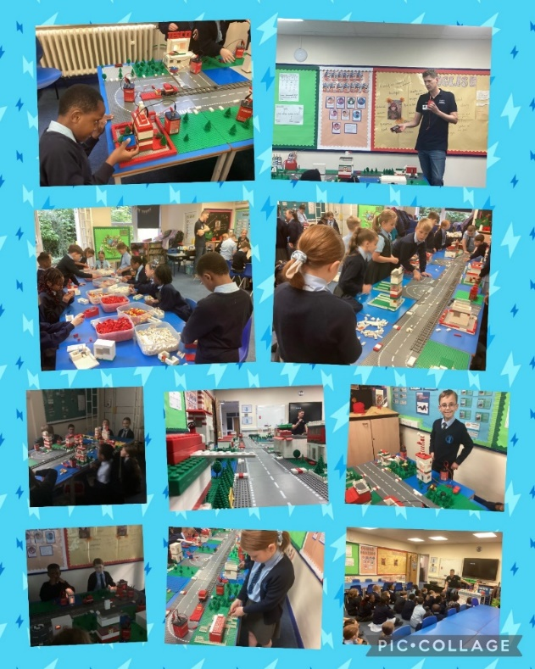
Sound Workshop
For the launch of the science topic, Sound, Sam the Sound Man came into school and demonstrated how sound travels through solids, liquids and gases. We looked at different soundwaves and how changes in a noise make them look different. We made our own musical instruments.
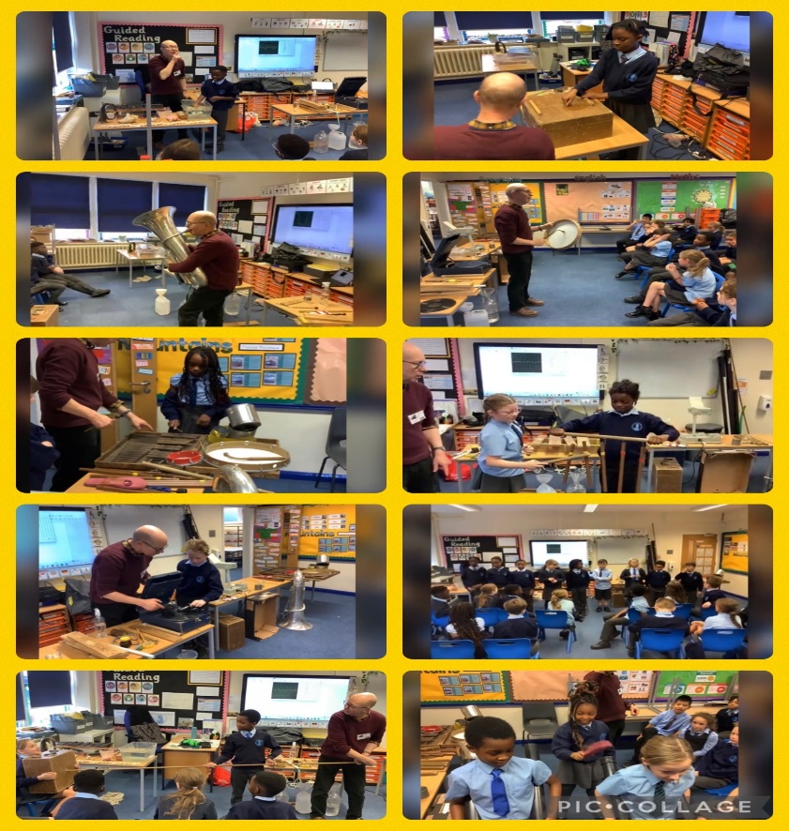
Ancient Greece
Year 4 had an amazing day learning about Ancient Greece. We looked at artefacts, played games, performed a play, learned a dance and made our own coins out of clay.
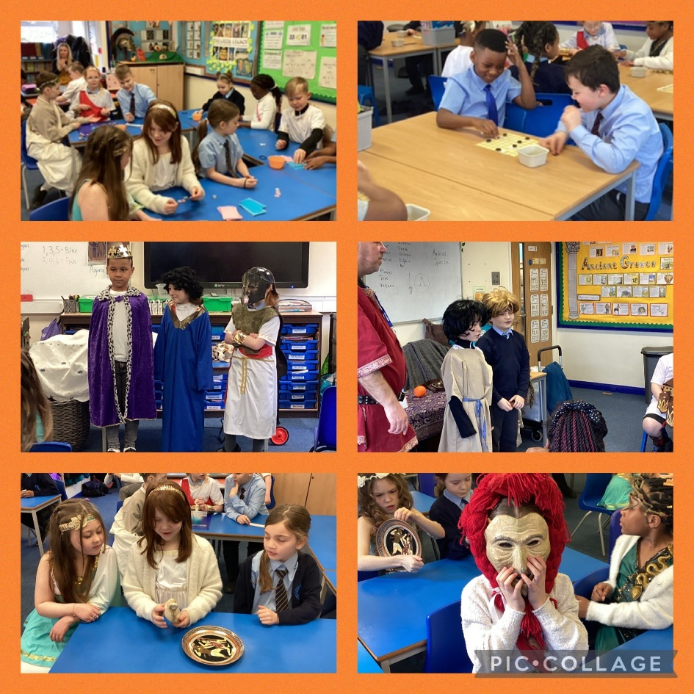
Bolton Abbey
Year 4 had a fabulous time at Bolton Abbey using their subject knowledge and key vocabulary to complete fieldwork as part of their river study. Not even the rain could stop us!
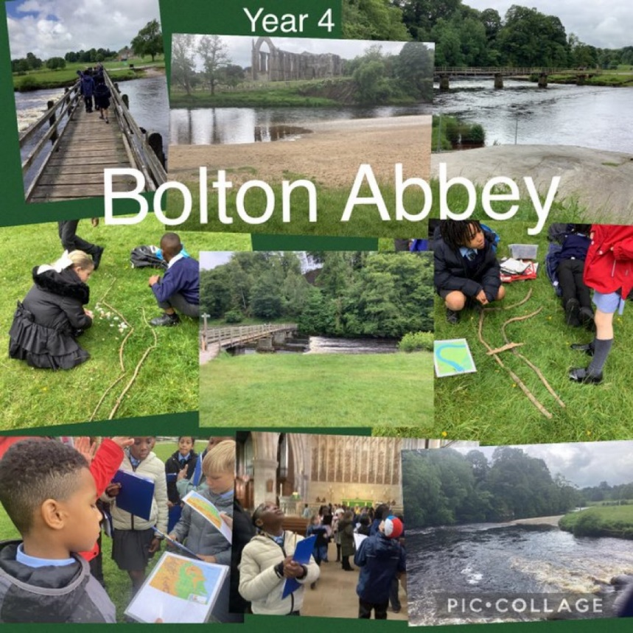

Year 5
Manchester Carnival Day
Year 5 had the best time celebrating Manchester Carnival Day. We have been learning all about Brazil in geography and the Rio Carnival. As a half-term holiday project, we created costumes for a carnival with a Manchester theme. We had so much fun!
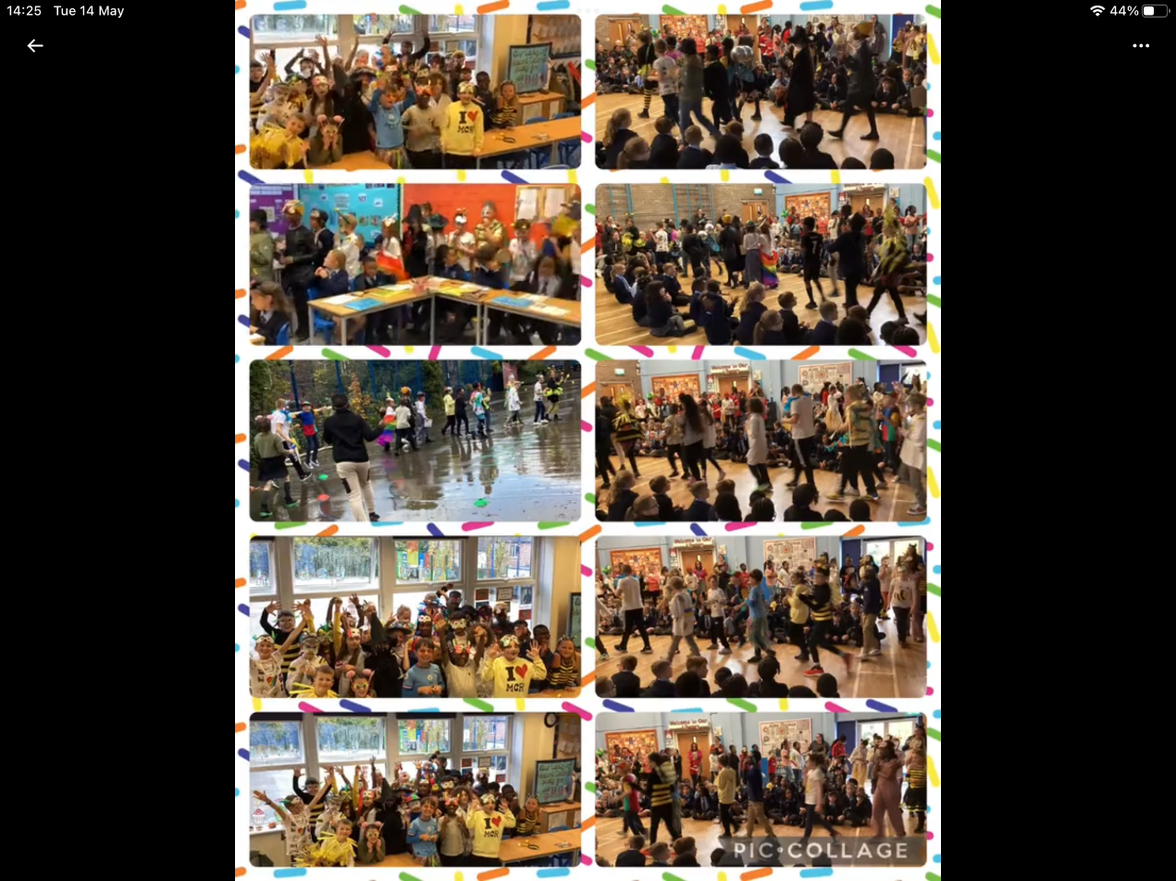
Bikeability
Year 5 took part in ‘Bikeability’. This cycle training programme equips children with the skills, knowledge and understanding to cycle safely on the roads.
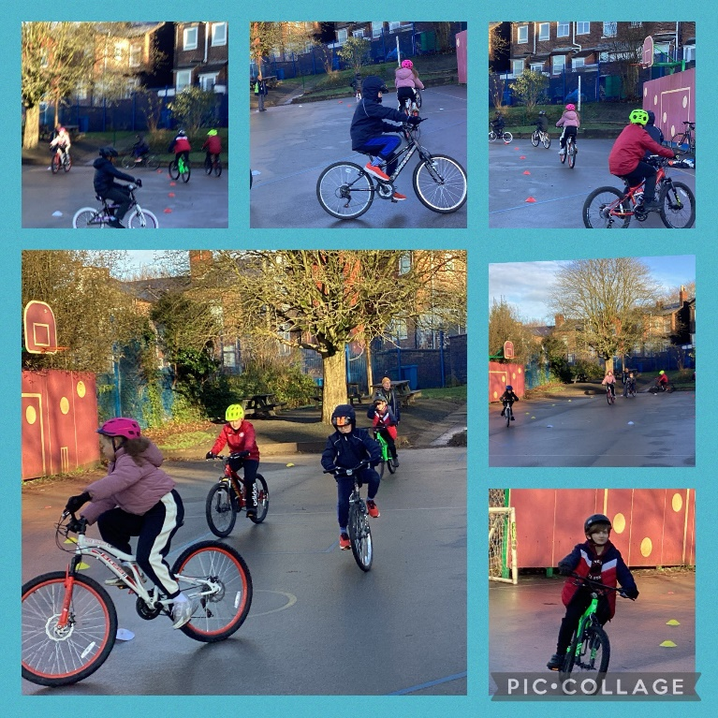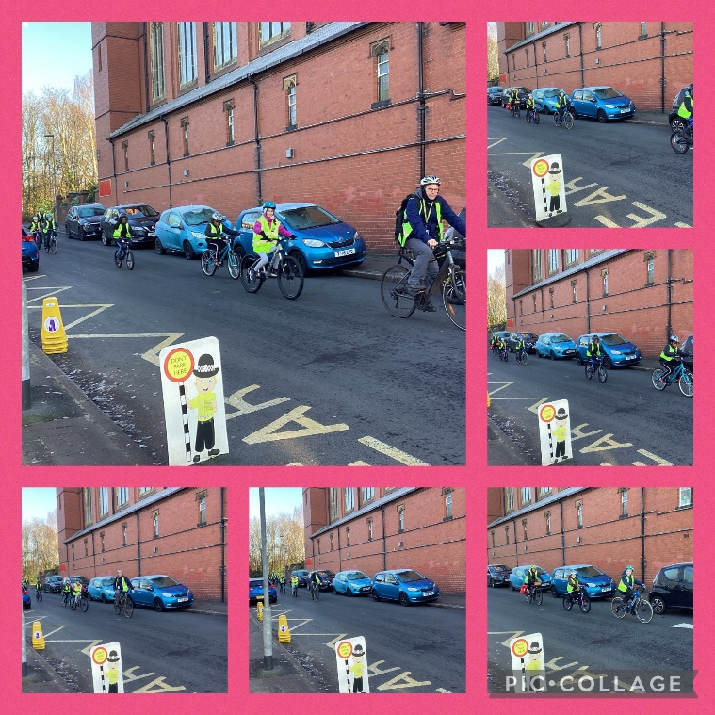
Mission Mars – Mechanisms and Movement
Year 5 had a fantastic workshop with Stephen from Creative Builders. It really helped us to understand that some mechanisms allow a smaller force to have a greater effect. So much fun!
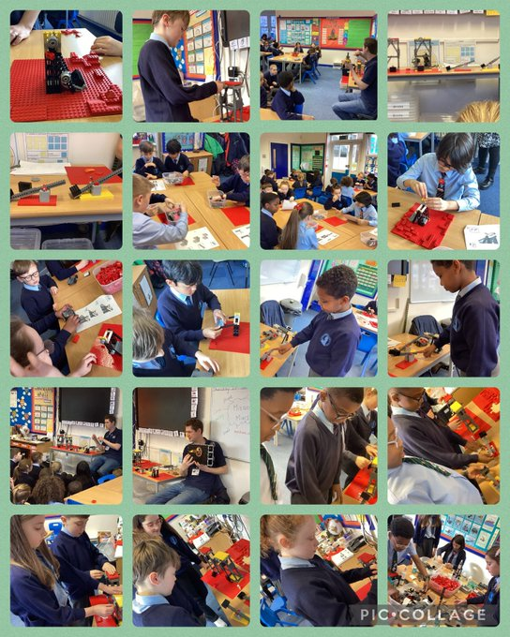
Space Challenge
Year 5 enjoyed the Road to RIAT STEM Space Challenge. We created a variety of rockets and tested them; to find out which design was the best by calculating the speed. We also started to design sustainable aircrafts. We worked on this over a week.
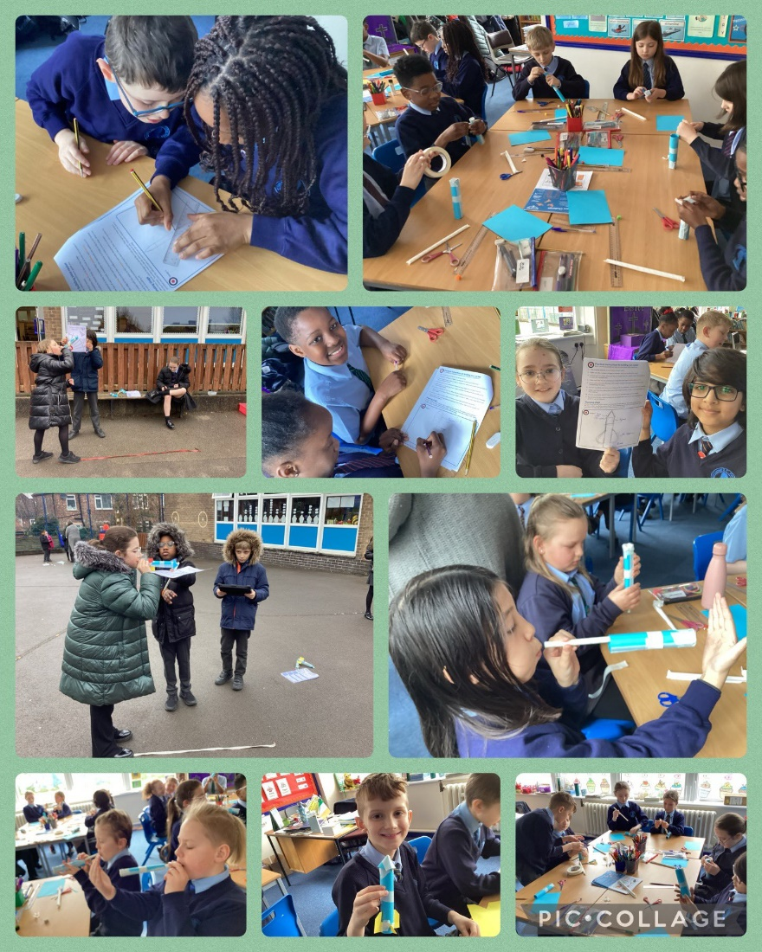
Rockets
Year 5 had a wonderful day with Amanda Morrow designing, making and launching rockets as part of our D&T and Science topics. The children learnt so much and had such fun in the process.
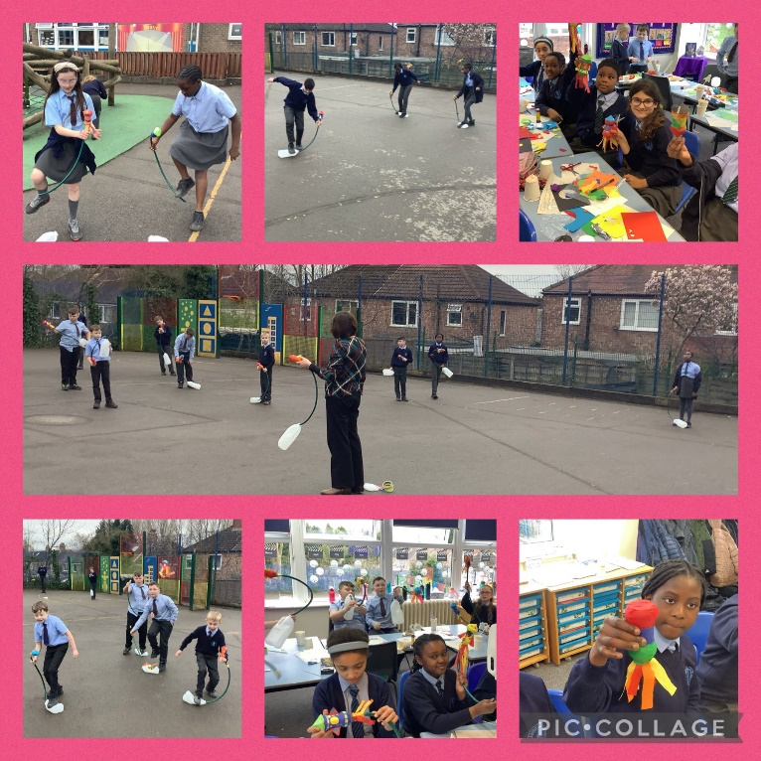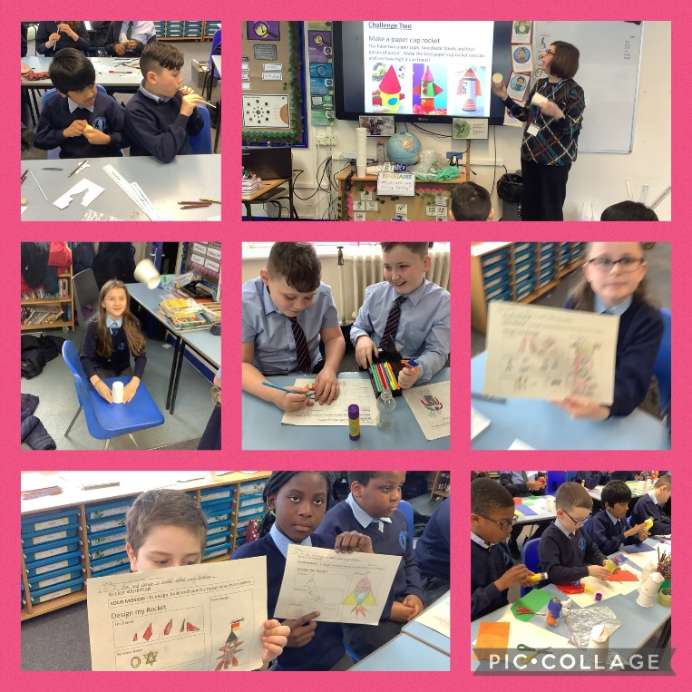
Wise Old Women Workshop
Year 5 took part in the Wise Old Women Workshop led by Proper Job Theatre. The children explored the themes of sustainability, environmental change and challenging the stigma and stereotyping of old age. The children had brilliant ideas to share.
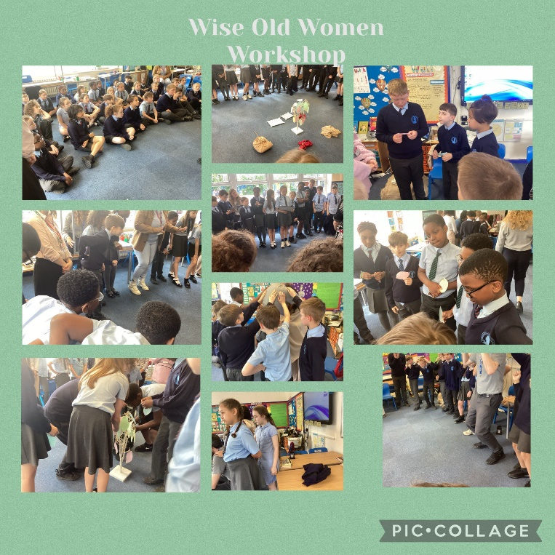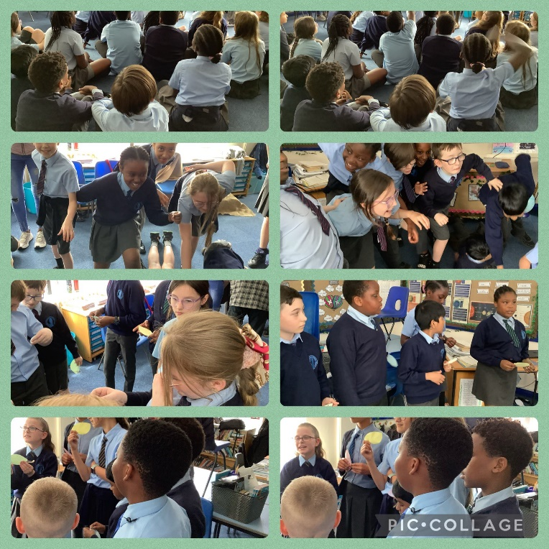
NatWest
Year 5 had a visitor from NatWest bank. We learnt about energy costs in the home and how they can reduce these costs and help the environment at the same time. They came up with some brilliant energy saving ideas.
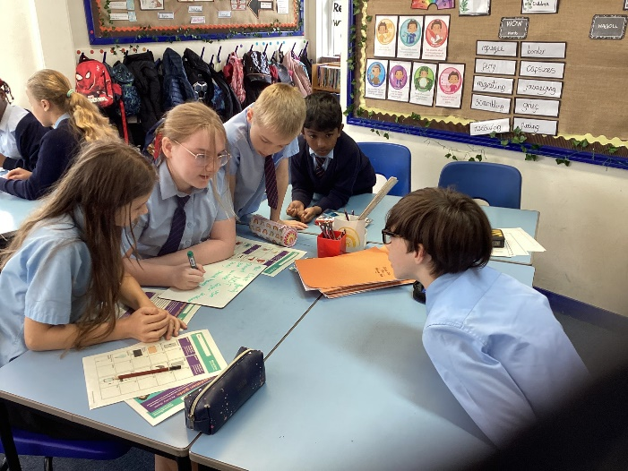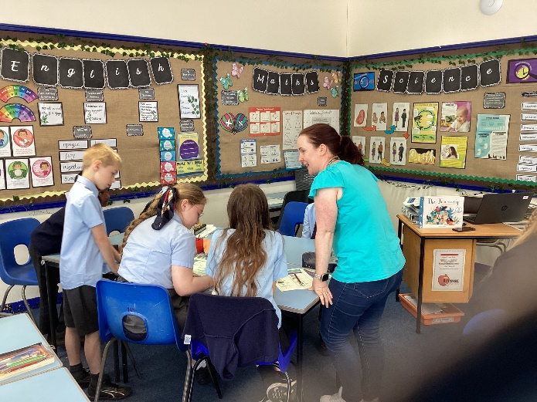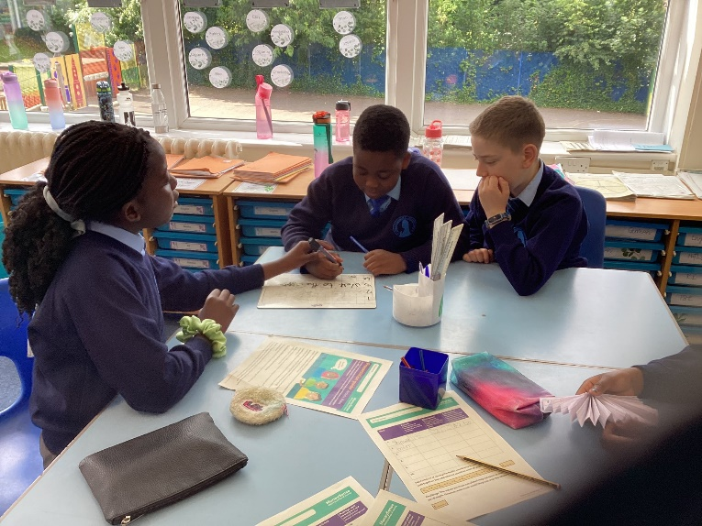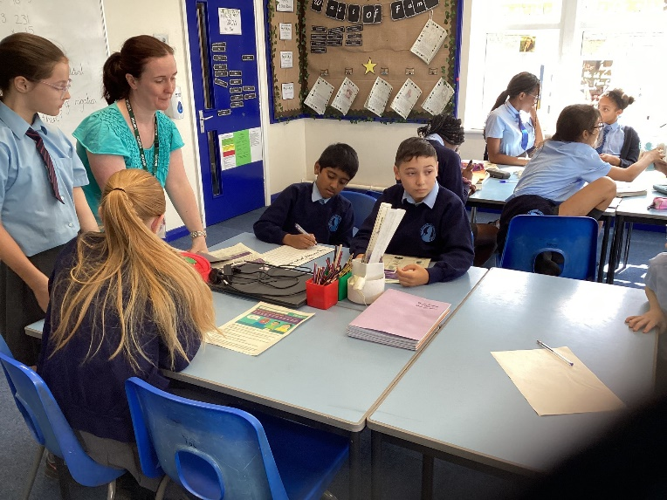

Year 6
Geography Field Trip
As part of our Geography topic on the local area, year 6 have conducted field work around Boggart Hole Clough and Harpurhey Shopping Centre. This walk was to support our geography unit on the local area and field work skills. We had a great time learning about the human and physical features in their local area. We created a 360 degree drawing of Boggart Hole Clough and made notes which will support the formation of a field work questionnaire for the local area.
“We observed, measured and recorded human and physical features in the local area.”
“We were able to identify many geographical features of the local area and are now able to use these to plan a fieldwork survey."
“There is a lot of physical features in Boggart Hole Clough but there are a lot of human features at Harpurhey Shopping Centre.”
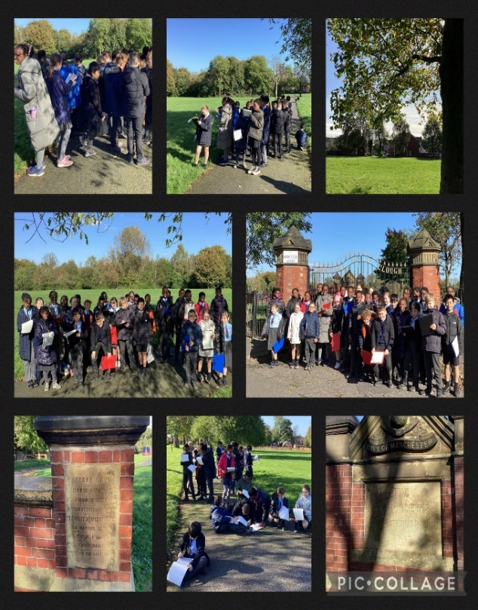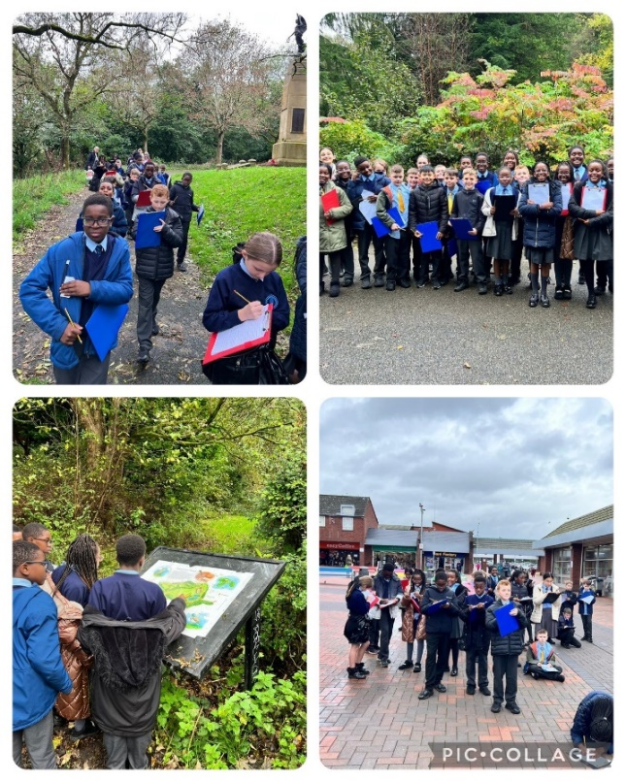
Author Zoom – Hannah Gold
Year 6 enjoyed a fantastic online lesson with Hannah Gold following the launch of her new book, Finding Bear. She gave us great advice about planning, writing and editing our own work. We also took part in her quiz about climate change and looking after our planet.
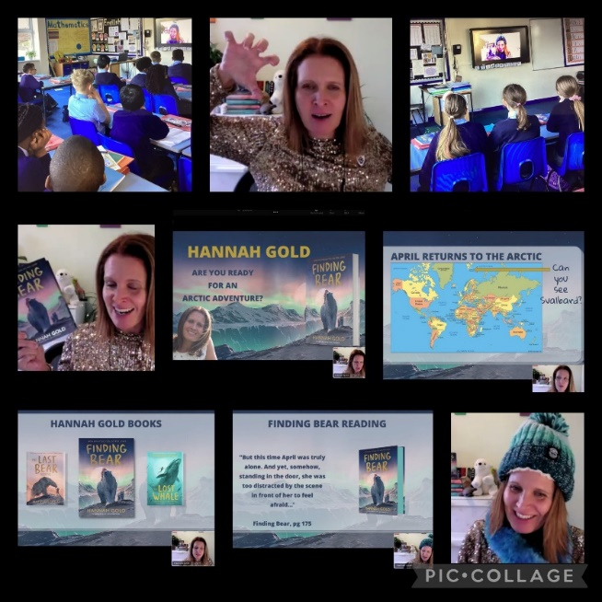
Manchester Christmas Markets
Year 6 visited the Manchester Christmas Markets. We experienced what a German Christmas market was like and managed to practice our German at the stalls. We also had the opportunity to explore our local city and see the Abraham Lincoln statue which we have learnt about in History.
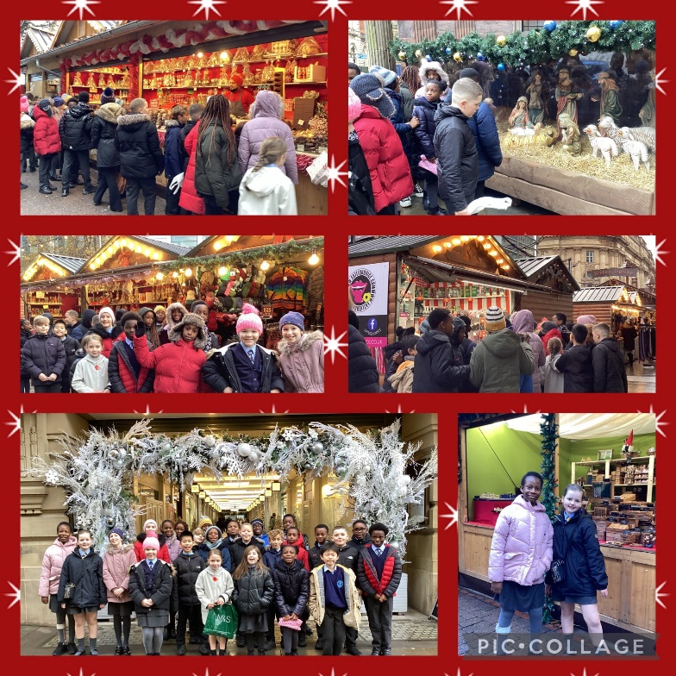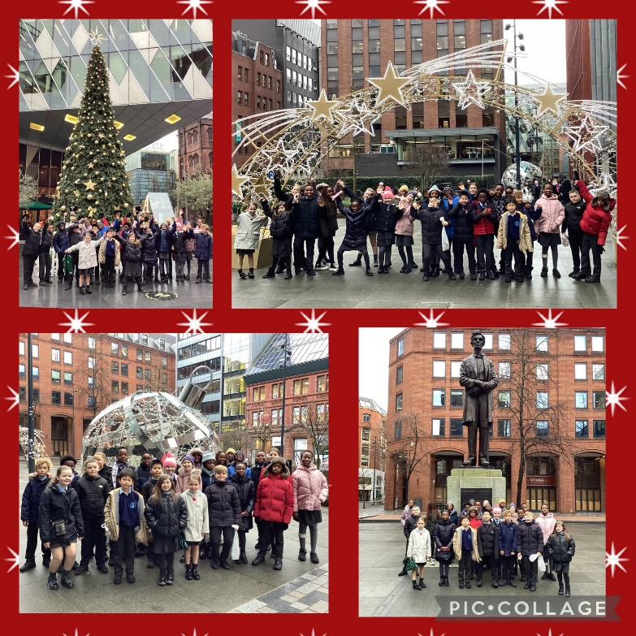
Manchester Central Library
Year 6 had a fantastic afternoon at Manchester Central Library. We met poet Oliver Sykes and illustrator Ian Morris. Oliver read a selection of his poems from his book, ‘We Are Family’ and Ian showed us examples of his beautiful artwork.
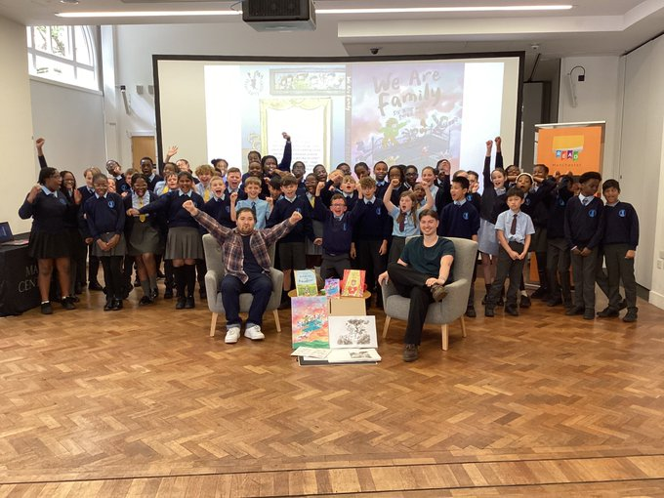
NatWest
Year 6 enjoyed a wonderful banking workshop led by two volunteers from NatWest with a focus on fraud investigation and how to keep their money safe. They finished the workshop by presenting the story as a newsreader. We were blown away by the children’s presentations.
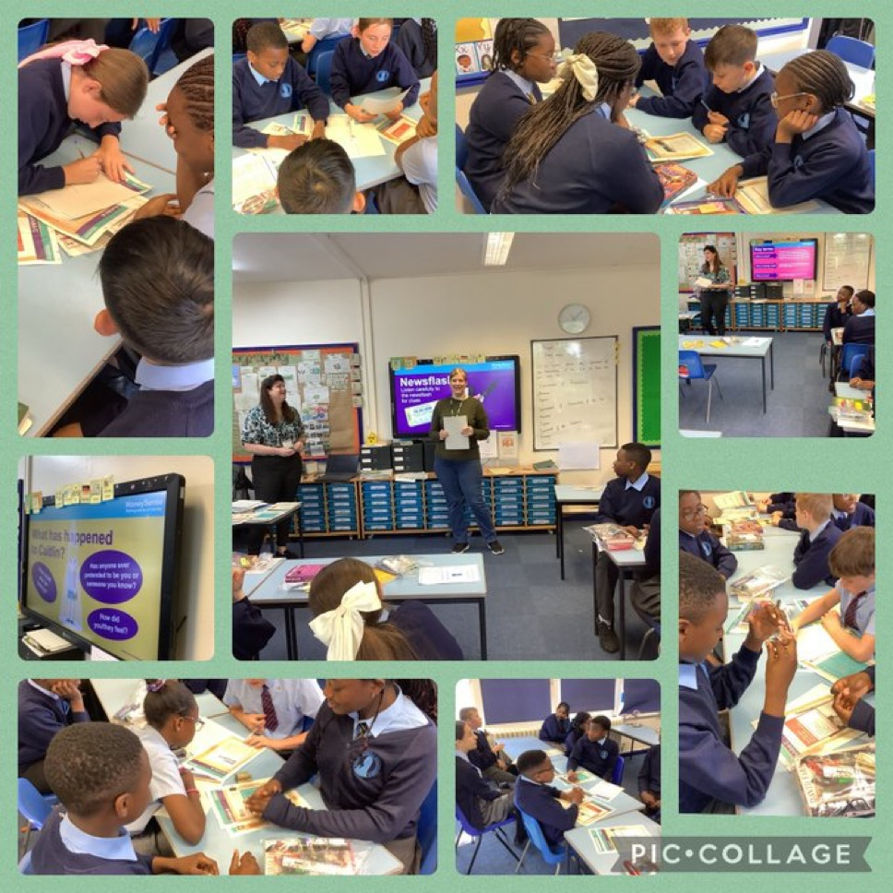
Kininso Kincepts
Year 6 had a brilliant morning working with Joshua and Angela from Kininso Kincepts supported by Z Arts. The children enjoyed creating their own unique interpretations of words and phrases using song, movement and noise.
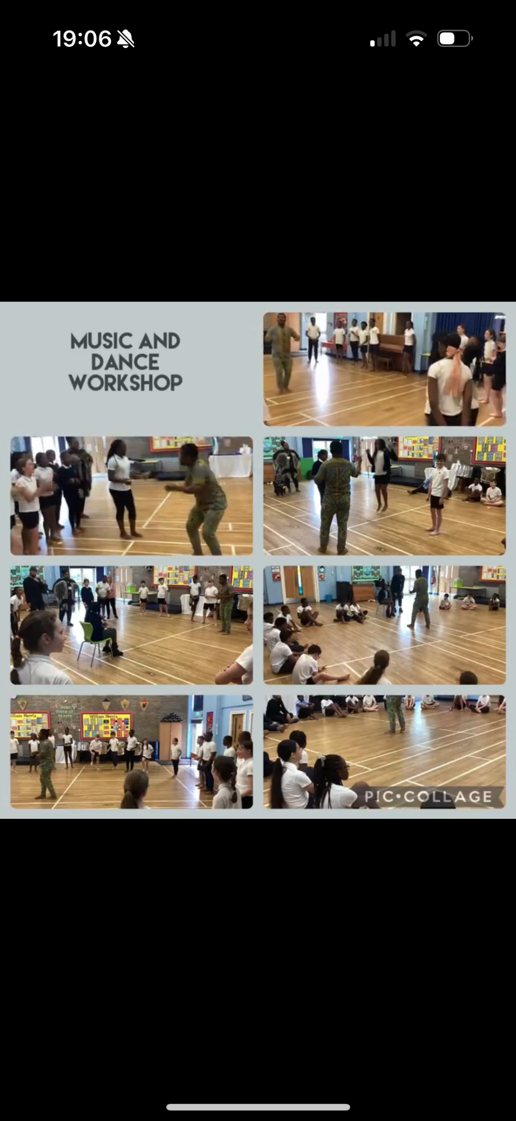
Barclay’s Bank
Year 6 had a fascinating morning working with Mrs Wright from Barclay’s Bank. She told us about financial and cyber security. We were fascinated with all she had to teach us. We finished the session with a quiz about online financial safety in which we scored 100%.
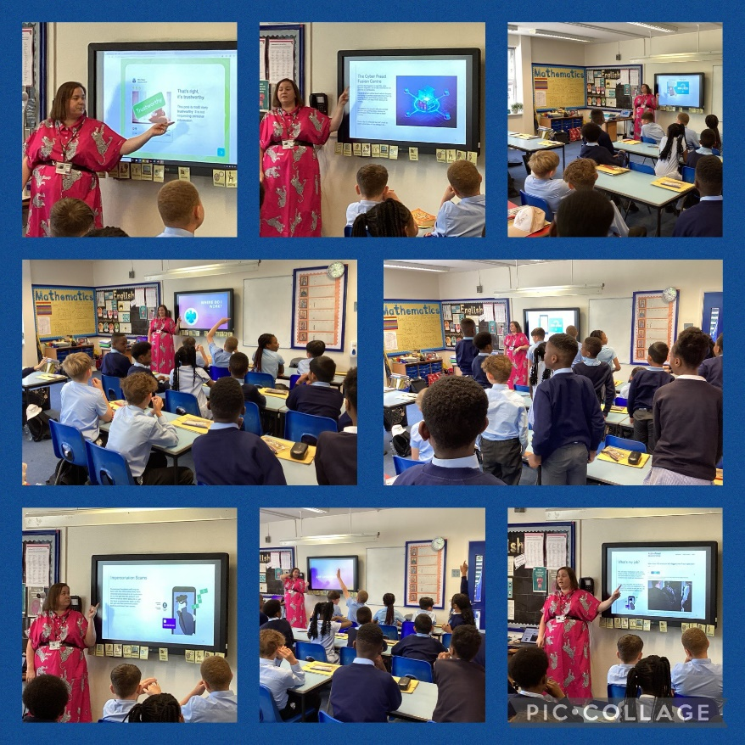
Alison Cope
Year 6 welcomed Alison Cope to lead a workshop all about keeping safe and the dangers and influence of social media. Alison’s story was extremely powerful and it is so important that our young people hear her message.
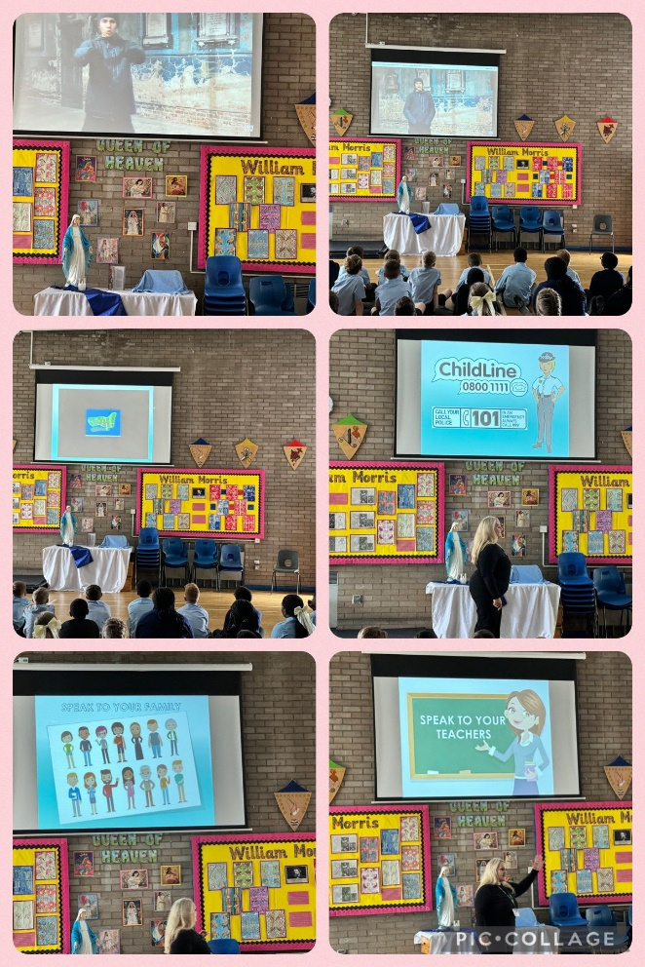

Whole School
R.U.D.E Workshop
Year 5 and 6 took part in a workshop called ‘R.U.D.E – Respect, Understanding, Danger and Equality’ delivered by Dean Coady OBE. This workshop developed awareness of dangers on the street and keeping safe. It was a fabulous workshop and we will build on this learning in PHSE.
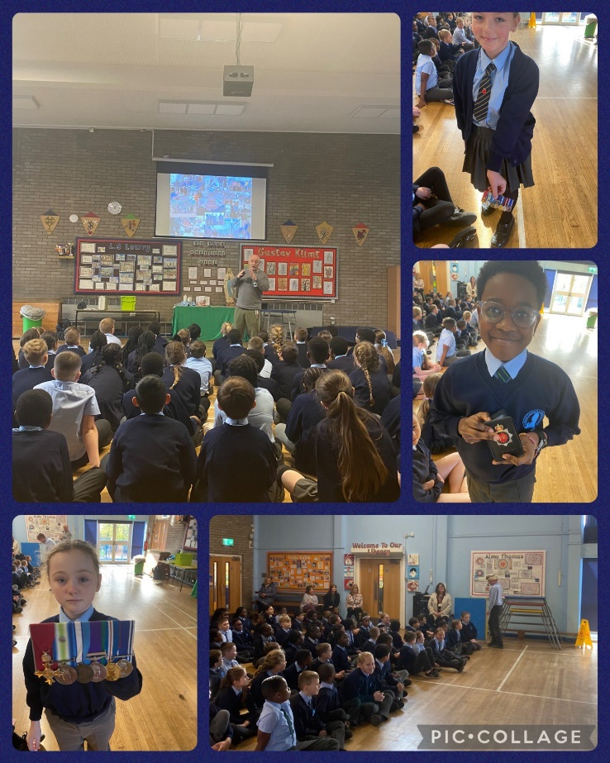
Well-being Workshops
At the start our Spring term, both KS1 and KS2 took part in well-being workshops each week delivered by Fifth Movement. We concentrated on our breathing and completed meditation exercises. We really enjoyed our sessions with Judith.
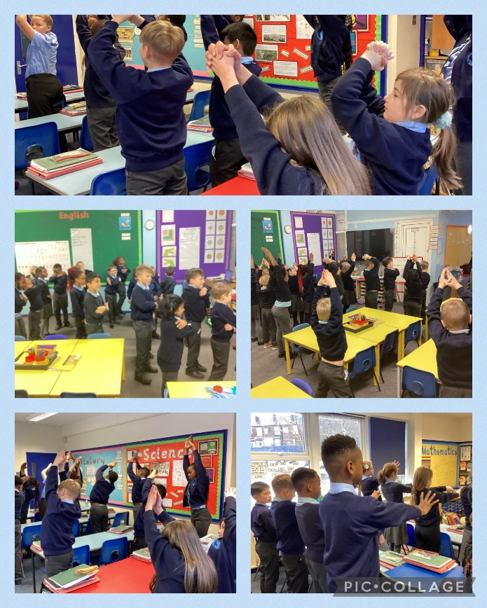
Sean Perkins
Sean Perkins, a local author, visited our Infant Department to share his new book ‘Oscar and Ben, the Birthday Party’. We loved listening to his story and discussing the characters, we had so much fun.
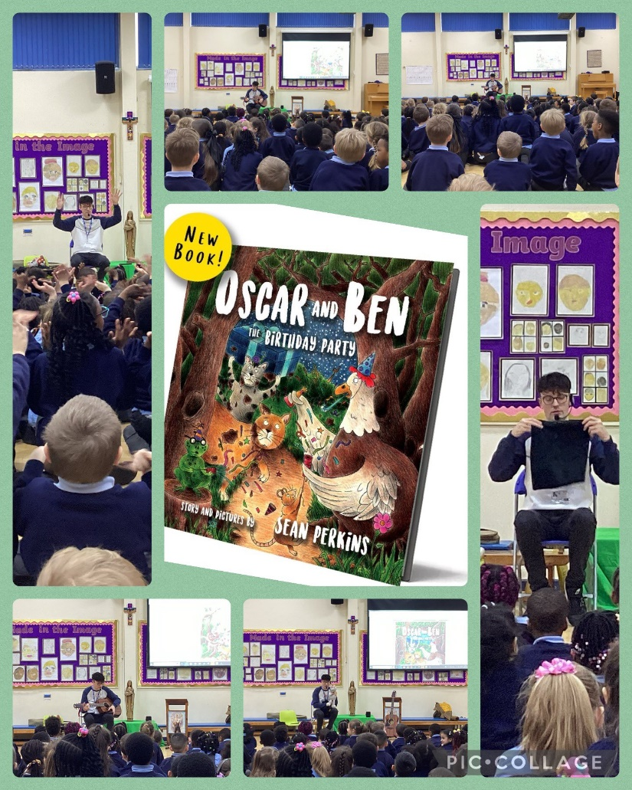
Big Bedtime Read
Our children came back to school in the evening for a bedtime story. Snuggled in their cosy pyjamas, the children enjoyed a story with milk and a cookie.
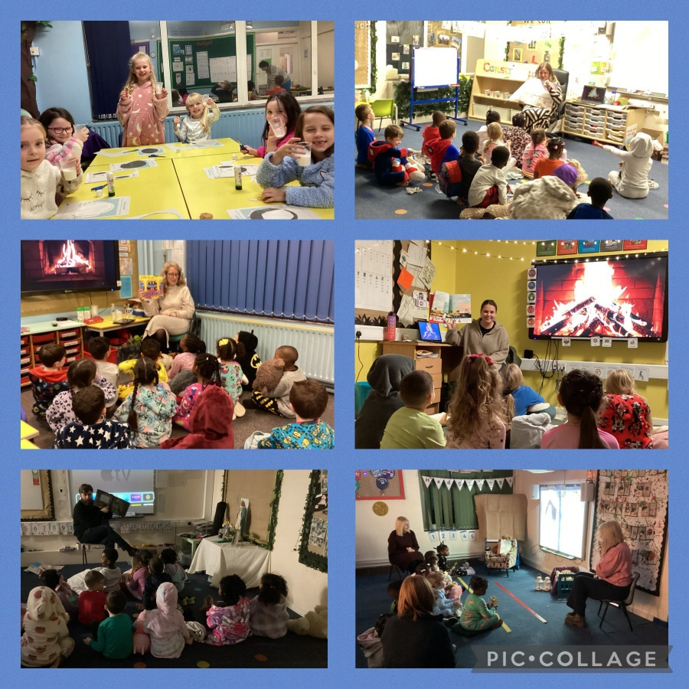
Poets
The children in the Junior Department were visited by two Manchester-based poets called Louise and Zena. The poets spent the morning with the Year 5 children, where they performed some poetry and created their own poems using the ‘swag bag’. In the afternoon, Louise performed some poems for the whole school and the KS2 children were given the opportunity to ask her some questions.
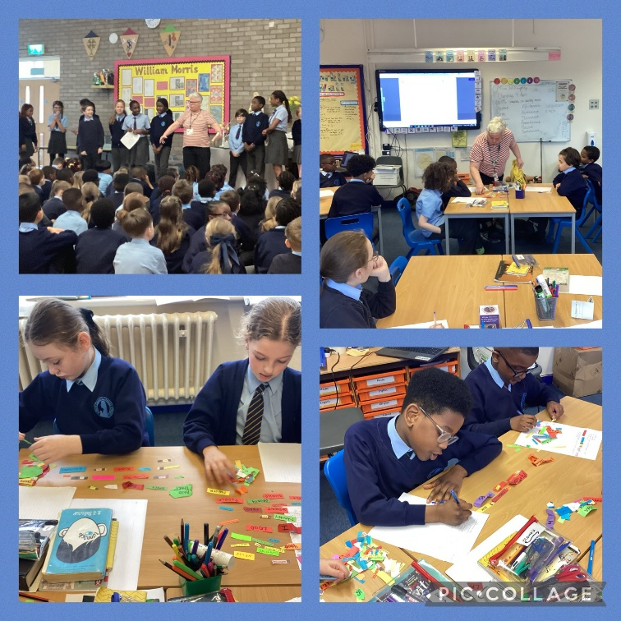
Career and Aspirations Day
Our careers and aspirations day was launched in both departments with a special assembly. A range of professionals shared their experiences and insights about their careers. Kate – our drama therapist – spoke to year 5 and 6 about another one of her roles working as a psychological therapist at Manchester Prison. She spoke about what her job role entails and her journey to this point. Another aspirational person that spoke to us was Keira Forsythe. She spoke to the children about her disability and career. She talked about how her resilience and determination has led her to fighting the stigma surrounding her disability and earning a place on the GB Taekwondo team. We really must reach for the stars.
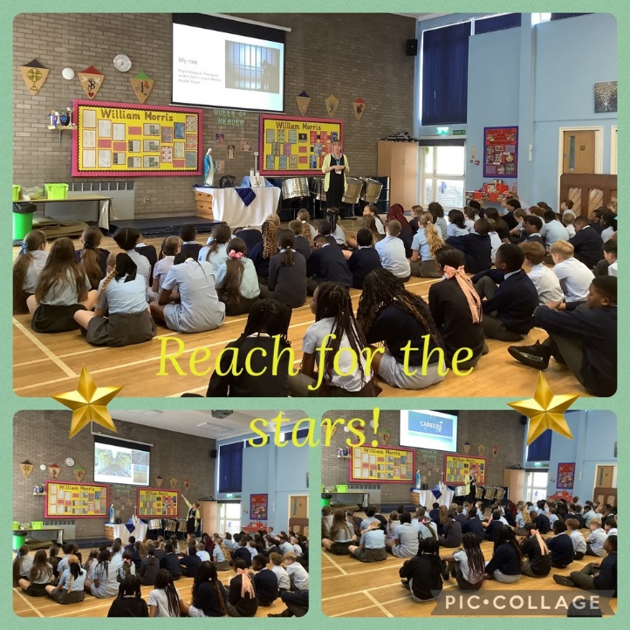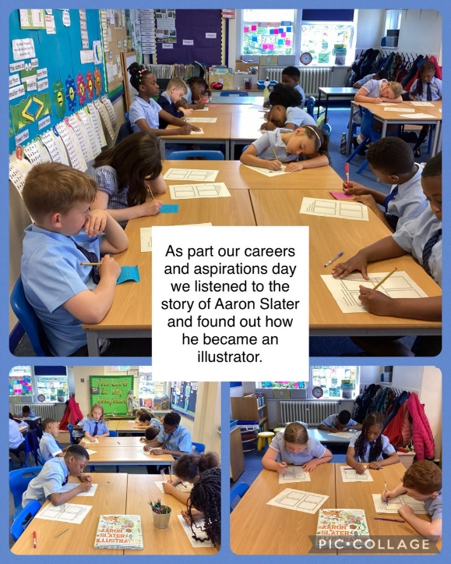
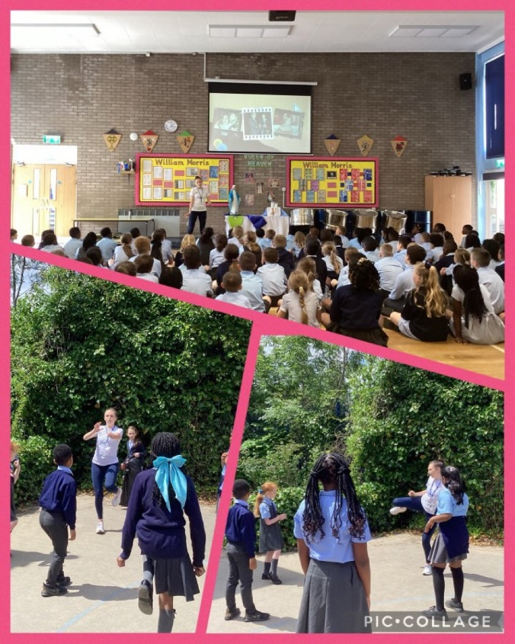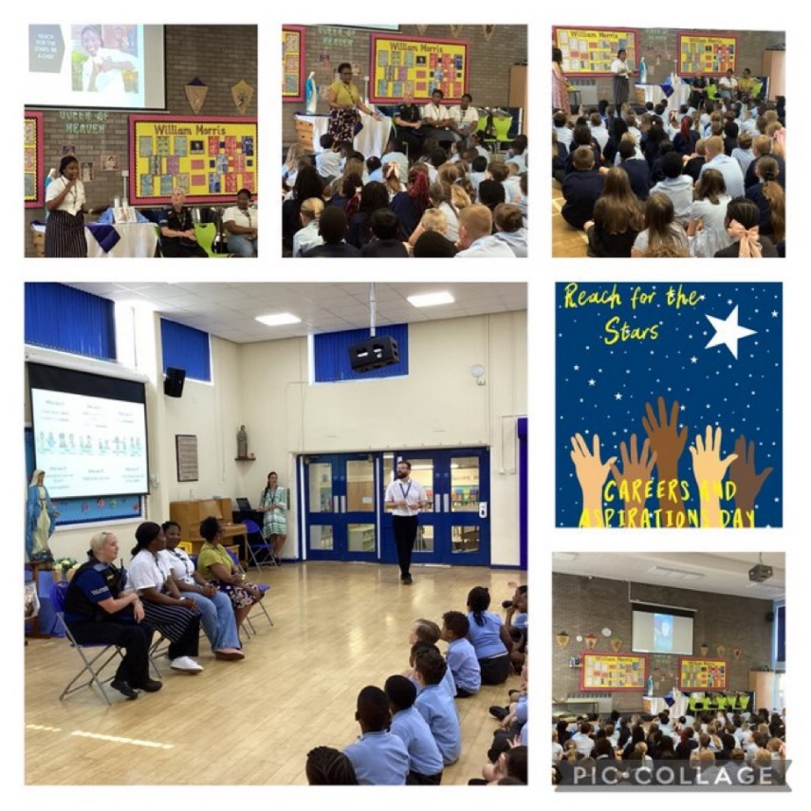
World Mother Tongue Day
For Mother Tongue day, the children celebrated by coming into school in traditional dress from their culture. We also completed language activities like making poster fact files on different countries, poems about languages, investigating flags and creating word clouds of hello in many languages. It was wonderful to celebrate our wide culture in school and see so many different traditional clothing.
